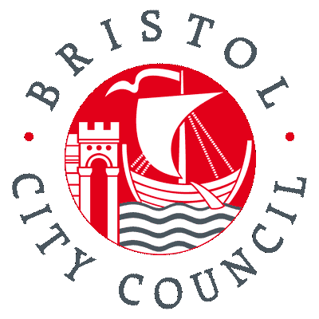
Bristol City Council Equality Impact Relevance Check
This tool will identify the equalities relevance of a proposal, and establish whether a full Equality Impact Assessment will be required. Please read the guidance prior to completing this relevance check.
What is the proposal?
Name of proposal | DfT National Productivity Investment Fund Bid
Please outline the proposal. | Bristol City Council is submitting a bid as part of the above DfT NPIF as follows;  - Upgrade and repair various key junctions across the region;  This is a bidding process so there is no guarantee of funding being provided or certainty that schemes will be delivered
What savings will this proposal achieve? | No specific financial savings identified in short term. However in longer term this capital investment, should we be successful in our bid, will secure the long term life of these transport assets for Bristol City Council and provide support to the economic vitality of the city its residents, businesses and visitors.
Name of Lead Officer | Shaun Taylor, Highway Maintenance Group Manager

Could your proposal impact citizens with protected characteristics?
(This includes service users and the wider community)
Please outline where there may be significant opportunities or positive impacts, and for whom.
WECA – Junction Improvement Schemes: Various interventions at key junctions / routes, Improvements to traffic signals to allow better traffic flows, Improvements to junctions to give better priorities to buses and to improve pedestrian flow. We will also use the opportunity to replace other end of life assets at these locations to reduce the revenue burden on the authorities.
Please outline where there may be significant negative impacts, and for whom.
There may be significant negative impacts during construction when lane closures may have to be introduced. This will affect all road users which will potentially include members of all citizens with protected characteristics.

Could your proposal impact staff with protected characteristics?
(i.e. reduction in posts, changes to working hours or locations, changes in pay)
Please outline where there may be significant opportunities or positive impacts, and for whom.
Only in the same way as anybody from a protected characteristic group will be impacted as detailed above.
Please outline where there may be negative impacts, and for whom.
Only in the same way as anybody from a protected characteristic group will be impacted as detailed above.
Is a full Equality Impact Assessment required?
Does the proposal have the potential to impact on people with protected characteristics in the following ways:
- access to or participation in a service,
- levels of representation in our workforce, or
- reducing quality of life (i.e. health, education, standard of living) ?
Please indicate yes or no. If the answer is yes then a full impact assessment must be carried out. If the answer is no, please provide a justification. | Yes in terms of the first two categories. However at this time this is a bidding process so there is no guarantee of funding for schemes. In addition the timescale for submission of bids is very tight. Cabinet approval was only issued on the 8th March and bids have to be submitted by the 24th March.  A full impact assessment should be carried out if the bid is successful.  No in terms of reducing quality of life. The scheme will provide greater access to health, education and standards of living through improving access to these facilities.
Service Director sign-off and date:  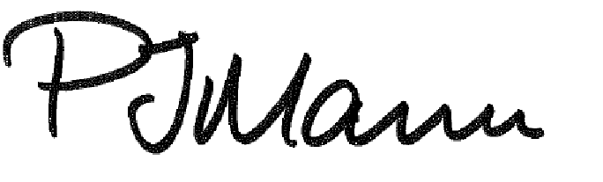  27/6/17 | Equalities Officer sign-off and date:  If the bid is successful please could you complete an EqIA. Cherene Whitfield. June 2017.

