Universities Engagement Project
Encouraging Sustainable Travel at Transitions Points - Literature Review

James Morvan
July 2013

Contents

- Background

  - Sustainable Travel Hierarchy

- Existing Travel Behaviour

  - University Context - Student Travel Survey Results
  - University Cycling
  - Other University travel modes
  - Summary
  - Further Research Questions

- Perceptions of Travel

  - Behavioural Insights
  - Perceptions and Barriers of Cycling
  - Perceptions of Other Travel Modes
  - Further Research Questions

- Intentions of Travel

  - Habits and Transitions
  - Consideration of Travel – Timing
  - Further Research Questions

- Influencing and Communications

  - Influence
  - Information Sharing
  - Suggested Approaches
  - Segmentation
  - Further Research Questions

Background
The university engagement project is funded for two years by the LSTF across both the University of West England and the University of Bristol. The main objective is to develop a toolkit of measures that can be used to encourage a positive sustained behaviour change in the transport choices of students. There is future scope to share the learning’s across other academic institutions in the West Region and beyond. The interventions will focus on transition points in students’ lives, targeting first and second year students.
This paper is a brief review of academic and industry sources with a summary of the two universities most recent travel surveys. The objective of the paper is to provide a background of existing research around travel and cycling and to articulate areas where further research is required (for the proposed primary research). The research is deemed necessary due to gaps in the literature, particularly around the young adult/student demographic where it has been shown behaviour is influenced in subtly different ways (Jessor, 1982). After a brief background on sustainable travel, the sections will cover existing travel behaviours, perceptions of travel modes, intention of travel modes and how to influence and communicate.

Sustainable Travel Hierarchy
Sustainable travel is defined here as a mode of travel that makes a positive contribution to the environmental, social and economic sustainability of the community. As a short-hand, sustainable transport can be usefully categorised using the below ‘Sustainable Transport Hierarchy’ image. This ranges from the least sustainable transport options (single occupancy car) to the most (active travel).
For further discussion on the sustainability merits of transport choices see Mackay (2008). A key goal for the overall project is to encourage transport change away from single occupancy cars, and where possible to promote cycling and walking above all other modes.

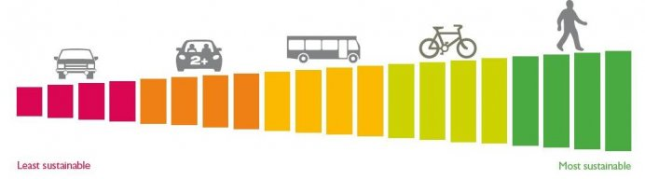
Image from exeter.ac.uk

- Existing Travel Behaviour
University Context - Student Travel Survey Results
The below table gives an indicative travel mode split for Bristol students based on the results of the 2011 University of West England (UWE) and the 2012 University of Bristol (UoB) travel surveys. The UWE survey measures the travel mode to the place of study and the UoB survey measures general student travel. UWE relied on a cordon count on a given day whereas UoB used an online survey with 2000+ responses. Due to the differing methodologies, we should be wary of making too many comparisons. Also, anonymous surveys results have been known to differ subtly from actual observed behaviour.

UWE 2011 |  |  | UoB 2012
Travel Mode | Student % |  | Travel Mode | Student %
University Bus | 37 |  | University Bus | 8.9
Other Bus | 6 |  | Other Bus | 3.4
Walk | 9 |  | Walk | 61.5
Cycle | 6 |  | Cycle | 10.9
Car on own | 27 |  | Car on own | 5.2
Car share | 15 |  | Car share | 3.1
Other | 3 |  | Other | 7

Least Sustainable Most Sustainable Least Sustainable Most Sustainable

The results show that the University of Bristol has a greater number of journeys at the more sustainable end of the transport hierarchy than the University of West England. This is most likely due to a number of key factors including the location of the main campuses, the distances of students from the place of study and the differences in restriction of parking in either area. Also the UWE survey excludes on-campus residents (mainly walkers) and excludes Bower Ashton campus students, where a 2008 survey has shown cycling rates in the region of 14% (higher even than UoB rates). Finally it should be noted that when UoB students were asked in the survey about specific journeys to their place of study, a lower 8% responded as cycling.
This gives the impression that cycling rates are probably more similar at the two universities than they first appear. However, the results suggest there is still greater scope for change at the University of West England, with 85% of surveyed students travelling by car or bus, compared to just 17% at UoB.

Cycling
The 2011 census shows that 2.9% of people cycle to work nationally, however in Bristol it is far higher at 8% (Web Ref 1). The Bristol universities are both close to the Bristol average (UWE at 6% and UoB at 11%) but there is potential scope to increase this. By way of example Cambridge has a cycle to work rate of nearly 30% and there are even higher rates in famously cycle friendly European cities such as Copenhagen, Amsterdam and Munster in Germany (Pucher and Buelher, 2007).

Gender and Cycling
National cycling rates for women are significantly lower than men, with only a quarter of bicycle journeys made by women (Web Ref 1). This is not the case in countries which have high levels of cycling generally, such as Holland, Denmark and Germany (Garrard, 2003). National female cycling rates are mirrored by those at the University of Bristol, results below from 2012 travel survey. The UWE travel survey does not provide a gender split.

The number of male students that ‘usually cycle’ (67%-100% of journeys) is double that of female students. Encouragingly, when combining answers of occasionally, sometimes or usually cycles, the figure is 20% for female students and 34% for male students. This suggests that similar numbers will have regular access to a bike. One strategy could be to target occasional cyclists to encourage a greater use of their bicycles (ie through marketing, organised bike rides, free maintenance, cycle competency classes, personal travel planning etc).

First Year Students and Cycling
Below is data for the segmented population of students in university accommodation. As the survey does not specify year of study, this metric is used as a proxy for 1st year students (it is noted that this is not a perfect fit).

Cycling rates for both males and females are both significantly lower for (presumed) 1st year students than the average student rate and the gender split is even more marked. This suggests that the best opportunities to increase cycling rates may be with 1st year students, and in particular 1st year female students. One assumption is that due to proximity of much of the 1st year accommodation (distance <2km), and the free bus pass for all 1st year students, walking and bus options are seen to be relatively attractive options.

Other Travel Modes – Background Info
Walking - Although walking is perhaps considered the most sustainable transport mode it is noted that it is very hard to encourage further take up of walking. In general walking as a commuting option is usually only considered for journeys of a close proximity to the home (<2km) (Web Ref 4)
Bus - The university bus routes are well marketed, increasing in popularity and have a team of people supporting them. It is therefore unlikely that the scope of this project will be able to further support or promote the bus. The main implication for the university bus may be the mode shift away from bus use to cycling/walking. This is likely to be more than off-set by a shift from car users to bus users due to upcoming changes to parking restrictions at both universities.
Car Share - It is thought that much of the student car sharing at the two main university campuses is arranged through informal, off-line relationships such as flat-mates, course-mates and friends. The dedicated car-share car park at UWE is self-policing (requires driver and passenger to press a button to lift the barrier) and consistently well used. There are currently no dedicated car-sharing spaces for students at UoB. It is considered that there is limited scope to increase car sharing due to parking facilities and restrictions at the universities.
Car Clubs – Similar to car rental/car sharing. There is usually a requirement of at least 1 years’ experience of driving, which rules out many students, particularly 1st years. This is not being strongly considered.
Other Modes - The UWE 2011 travel survey shows that car, bus, cycling and walking make up >95% of student transport modes, and the UoB survey >93%, so other modes will be ignored for this project (ie train, motorbike, home-working etc).
Other Journeys – The UoB travel survey asked the question ‘apart from when you are attending the university to study, what other/additional journeys do you make’. From over 20 options, the top answers were; Shopping (food), Evening Out, Shopping (non-food), visiting friends in Bristol, travelling home (ie family home), general leisure trips and the library. It is not understood what travel modes were used to make these journeys.

University Context - Summary
Due to the transition element of the project, initial emphasis will be on the first year intake. From the UoB travel survey results, cycling rates are shown to be significantly lower amongst this segment of the population. Also, in-line with national data, female cycling in this segment and across the total population is significantly lower than male cycling. To address this deficit, emphasis should be placed on understanding barriers and opportunities to encouraging student female cycling.
Of the two universities, UWE has a lower cycling rate than UoB and much higher car and bus rates, with expected reasons given earlier. This suggests greater opportunity for change at UWE. However, it must be kept in mind that one objective of the project is to develop a toolkit that can be used for other universities, so there should be a degree of balance between the two sites.
More granular information on student travel trends would be useful, and this will likely take the form of a limited base-lining exercise included in the stage 1 of the market research. This will help measure both the actual trend of transport mode and use as well as give further insight into the complex social aspects behind travel choices.

Further Research Questions – Existing Travel Behaviour
- How do prospective students currently travel (ie before starting uni) – how does this change when they get to uni?
- What are the main factors that lead to an increase in cycling rates from yr 1 to yr 2 students? How much of this is linked to the 1st yr free bus pass, access to a bike, access to secure storage?
- Why is the female student cycling rate lower than the male? (this will also be covered in sections on perceptions and intentions)
- Who are the students that drive? Why do they drive? – is this due to lack of alternatives, proximity, convenience, family culture of driving, who pays for the costs of the car?
- Other than gender, how else is existing travel behaviour segmented in the population? Domestic/international, faculty, campus, family home vs halls vs private accommodation
- What are main journey purposes during term time (lectures, sport, social, shopping)?
- What transport modes are used for the above journeys?

Baselining Questions from CTS – TBC
Some of these proposed questions will duplicate questions we already intended to include.
Before coming to UWE
- Please give postcode of address where you live before coming to UWE (for internationals we might need a country drop down list?)
- What methods of transport do you use to get around where you live (before coming to university)? - tick all relevant options from list
- Which would you say you use most frequently?
What method of transport did you use to go to 6th form/college? - tick one of following options (method used for longest part of journey)

At UWE
- Where will you be living next year at university? - sensible list of options (perhaps list of halls or ‘other’ for new students and list of areas of city for 2nd yr students – I doubt most will know their new postcodes)
- Will you have access to any of the following when you start your university studies - car, bicycle, moped/motorbike...(anything else)
- At which campus will most of your time be spent? - sensible list of options
- How do you expect to get to this campus - tick one of following options (include 'don't know yet')
- How do you expect to get around for other journeys in Bristol? - tick all relevant options from list

Attitudes
Please respond to the following statements based on your current understanding
- Driving a car is a good way to get around in Bristol (strongly agree....strongly diagree) (do not include don't know option) Buses are a good way....
- Cycling is a good way...
- Walking is a good way...

- Perceptions of Travel
Behavioural Insights
In the UK in practical terms policy makers are keen to pursue initiatives to get more people cycling and have sought to use theory and the available evidence from transport and other fields to develop guidance on behavioural change programmes. The UK Department of Transport Behavioural Insights Toolkit (DfT, 2011) is an example of this, and the below summary is taken from Chaterjee et al (2013). The Dft Toolkit identifies the following types of influences on behaviour and uses the example of cycling to work to illustrate these:

- Structural factors, i.e. physical/cultural constraints (e.g. speed and volume of traffic on route between home and workplace).
- Attitudes (e.g. whether like (the idea of) cycling to work).
- Norms (e.g. whether cycling to work is ‘normal’ for someone like me).
- Cost (e.g. cost of buying or maintaining bicycle).
- Habit (e.g. whether cycling to work is done regularly).
- Knowledge/awareness (e.g. whether know how to ride a bicycle on the roads).
- Capability and self-efficacy (e.g. physical capacity to cycle to work; whether feel confident cycling to work).

It will be useful to know which of these influences on behaviour are most important to a student audience to help plan interventions. For instance, although improvement of structural factors is outside the remit of this project, there is opportunity to promote improvements/alternative routes that already exist. Other important considerations are that individuals do not always perceive the relative costs of different behaviours accurately due to a lack of knowledge and awareness; and that humans tend to prioritise short-term costs and benefits over longer-term considerations (DfT, 2011). For more discussion on Habits and Norms see section 4 & 5.

Perceptions and Barriers of Cycling
Some recent research suggests image is being increasingly recognised as an important factor in influencing an individual’s likelihood to cycle (Daley and Rissel, 2011). In a recent study, Gatersleben and Haddad (2010) examined the views held by UK adults about the typical UK cyclist by exploring perceptions about possible cyclist stereotypes. Findings identified how negative cyclist stereotypes may act as a barrier to cycling uptake in non-cyclists.

Leonard et al (2011) explored the image of cycling using the theory of self-concept. This is a theory often applied to traditional marketing practice, whereby consumers are more likely to choose products or brands that ‘fit’ with the image they have of themselves (or an idealised image they attain towards). Leonard et al (2011) applied this to the area of travel mode shift (in particular, moving from driving to cycling). In marketing theory, product image consists of not just the image but the stereotype of the generalised users of the product (Sirgy et al, 1997). Applied to cycling, this means it is important to understand what perceptions and stereotypes people have of other cyclists, as this may impact the choice of whether someone starts cycling.
From the Leonard et al (2011) research, groupings of cycling stereotypes became apparent such as ‘environmental activist’ or ‘sporty commuter’. Many of these stereotypes have negative connotations; however findings showed the image of the ‘leisure cyclist’ out for a gentle ride had a more positive connotation. This may be more in-line with some individuals self-concept, so using the positives from leisure cycling may be a gateway to utility cycling. Chaterjee et al (2013) supports this, with findings from a qualitative study suggesting that leisure and fitness interests can often be a trigger for more regular utility cycling. The methodology for both of these studies was in-depth qualitative interviews, to allow allow for a deeper exploration into an individual’s feelings about a subject or situation Leonard et al (2011)
Rissel & Garrard (2006) point out that barriers and motivations to cycle are different for different types of cyclists. They identify three main groups: non cyclists, occasional cyclists & regular cyclists, all of which will have different barriers. Greig (2001) identified a number of predisposing factors that negatively impact on cycling. These are important to identify, in order that strategies can be developed that address them. Some negative predisposing factors are (not an exhaustive list);
- the belief that cycling is dangerous,
- the perception that great effort is required,
- the reaction to helmet wearing (a bigger issue in Australia, with mandatory helmet laws)
- limited secure storage,
- not being aware of improved cycle ways
- or the perception that cycling is something you do before you start driving.
- The fitness image of cyclists (for example, athletes or wearing lycra) can also be a barrier to those people who do not currently cycle.
Safety concerns, often arising from the speed and volume of traffic and not having designated space for people riding bicycles, and aggressive driving has been consistently identified as deterrents to regular cycling (Greig, 2001). It is worth noting that concerns about safety are higher among non-cyclists than regular riders (Rissel et al, 2002), with non-cyclists consistently overestimating the level of risk involved. People with varying levels of cycling experience perceive traffic safety differently. Based on qualitative research with women, Garrard (2003) suggests that this it is more to do with skills, self-confidence, experience and route familiarity – when these increase, traffic safety concerns decrease.

Perceptions of Other Modes – Car and Bus
There is a lack of research that addresses the emotional, cultural and practical reasons why some young people drive and others delay learning (Bird, 2013). Recent research focused on UWE students used the hypothesis that an increased awareness of climate change would have an impact on travel choices, and in particular a reduction in car use (Melia, 2011). This was not found to be the case; in fact UWE students had typical levels of climate change awareness amongst their age group, and this had no discernible impact on their travel behaviour. Best (2006) finds that cultural and family values around the car reflect its role in adulthood and independence for teenagers.
The literature shows no apparent clear factor why some young people take up driving. Bird (2013) states, decision making processes are complex involving both rational and emotional reasoning, deeply embedded in social and cultural processes (Bird, 2013). Furthermore, in some households, the parents are active in encouraging the take up of driving as a ‘rite of passage’ or even to support the family.
Again perceptions of travel are important, and it is not clear if the student demographic differ from the general population on this. Typical attitudes towards using the bus are negative, particularly by those who don’t use it (Gardner & Abraham, 2006), with a key reason cited as unreliability (Steg, 2003). It would be very useful to see how perceptions of bus use change after the first year of regularly using the university bus. It is not clear from the literature how important the peripheral benefits are of traveling by bus and car, such as the social element (talking to friends on the bus or during car sharing) or the ability to read (bus only!) and listen to music/radio.

Further Research Questions – Perceptions of travel
Image (perhaps for stage 2?)
- Do students hold strong stereotypes of people who cycle, drive or take the bus? What are these? Do these views change after the first year of university?
- How do different travel modes ‘fit’ with the image students have of themselves? and the image of their ideal selves (ie who they would like to be)?
Cycling Barriers
- What are the key perceived barriers to cycling? How do these correlate with regularity of cycling (non-cyclists, occasional cyclists & regular cyclists)? How does this differ between genders?
- Barriers to explore drawing on above; proximity – what distances are considered acceptable to cycle? Hills, weather, facilities, competence/fitness, access to a bike, route knowledge etc
Cars & Buses
- The perception of the cost of travel for different modes to and from university
- How important is the speed of traffic and journey times for bus/car?
- Perception of peripheral benefits of bus or car journeys (as above)
Non-car drivers-
- Students without a car at uni – is there an ambition/desire to acquire a car?
- What type of journey would you use a car for?

- Intentions of Travel

Habits and Transitions
Daily travel behaviour, in particular mode choice, is seen as a habitual act, to the extent that the prospect of change is inhibited or prevented (Verplanken et al, 1997, Kenyon and Lyons, 2003). The Dft Behavioural Insights Toolkit (DfT, 2011) notes that timing is important for breaking habitual behaviour with moments of change (‘periods of transitions such as going to university, starting work, moving house, changing job, or retiring’) providing ‘windows of opportunity’ when behaviour is consciously considered. Ouellette & Wood (1998) support this, and suggest two criteria for breaking habitual behaviour are a change in situational context and an increase in consciousness of the behaviour. This has been shown in practice in the review of the ‘Effects of Smarter Choice Programmes in Sustainable Towns’ (Sloman et al, 2010). In this study it was noted that the biggest falls in car driver mode share were among groups at either a point of change in their lives or at a reduced income.

Consideration of Travel - Timing

Stanbridge and Lyons (2006) research investigated travel behaviour consideration during the process of residential relocation. In-depth interviews with house movers has shown that consideration of travel issues before moving may be more significant in altering travel behaviour than the change in situational context itself. In other words thinking about moving house could have a bigger impact on travel choices than the actual house move. The researchers developed a Residential Relocation Timeline (RRT) to show the stages and travel thought process during relocation.
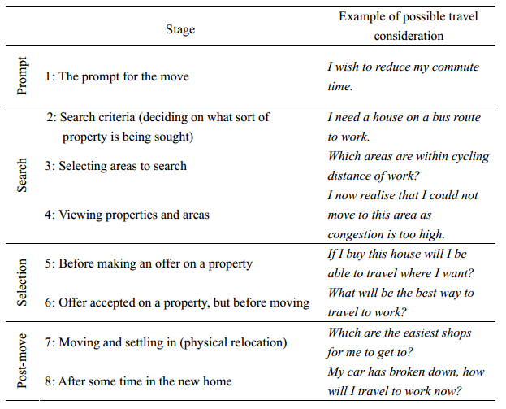
Results show that stages 2-4 are when the majority of respondents were cognitively considering travel choices. As a word of caution it should be noted that for typical residential relocations, travel considerations are rarely the main priority (Molin & Timmermans, 2003).

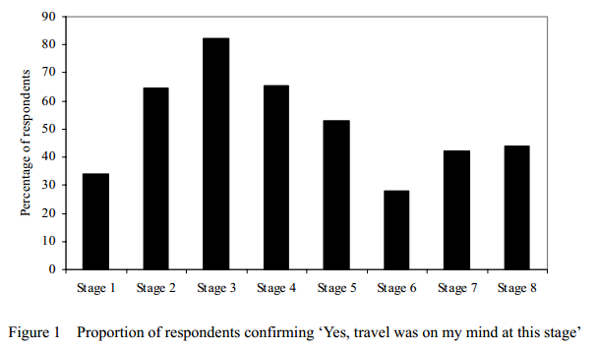

It is noted that although the above describes research focused on residential locations, there is a lack of research around the specific impact on travel choices during transition points in the lives of young students (typically 18-21). In particular this project is concerned with the initial move to university and the move from halls of residence to private accommodation in the 2nd year.

Further Research Questions - Intentions of Travel
There is a research requirement to investigate the thought process around travel at transition points
- How high a priority is travel when selecting a city, a university, and location of accommodation? How does the relative priority of ease of travel relate to the proximity to campus/city centre (bars/shops etc)?
- When does the travel consideration thought process begin? How closely does it mirror Stanbridge and Lyons (2006) residential relocation timeline? The answers to this will help shape the timing of interventions.
- How is the intention of travel mode linked to the perceptions of travel mode (above section)? I.e. Are positive pre-existing perceptions of cyclists a predicator of an intention to cycle, are negative perceptions of buses a predicator for an intention of driving or cycling?
Specific to pilot projects
- Would you prefer a free university bus pass or a free bicycle (with all the cycling essentials and 15 days free bus travel) Why - What are the important factors?
- Would you be interested in joining in led bike rides from halls to campus to help learn the route?
- Would you be interested in group leisure rides organised by the Uni/SU?
- Would you be interested in cycle training/road awareness training?
- Would you be interested in bike maintenance training if subsidised/free?

- Influencing and Communications
Influence
Through our social interactions about travel we may exert not only an informational influence on one another but also a subtle normative influence (Deutsch & Gerard, 1995). Informational influence is based on the acceptance of information obtained from others as evidence about reality, whereas normative influence is based on the need to conform with the positive expectations of others, particularly in a group environment. Although both can operate in parallel the importance of each will vary, given the situation.
This may be particularly important in this project given the young student demographic. Evidence continues to grow linking neurological development processes during puberty through to early adulthood, with certain characteristics such as increased risk taking (Johnson & Jones, 2010). Adolescents tend to base behaviour on perceived benefits rather than perceived risks – especially if benefits are short term and risks are long-term (Goldberg & Halpern-Fisher, 2002). If negative consequences are not experienced after experimenting with behaviour, this may reinforce perceived benefits. This may have implications around messaging (ie health implications of travel choices and enforcement of parking restirctions/fines).
Furthermore, in a highly social world, establishing autonomy, gaining peer acceptance and shaping identity are key factors in establishing future and current success (Jessor, 1982). Adolescents and young adults often have different criteria for ‘desirable’ consequences than adults, associated with conformity and peer approval (Bauman and Emnett, 2003), or of self-identity especially in the presence of friends (Mckay & Coben, 2002). This may mean that social norms may be relatively much more important to the student demographic than informational influence, compared to the general population. See Bird (2013) for greater context of the above summary.

Information sharing – word of mouth
One key mechanism for social interaction is the role of word of mouth, which has been studied in fields as diverse as health, consumer studies and tourism and has been found to exert a significant influence (Bartle et al, 2011). Within the realm of travel, there is less research, however Bartle et al (2011) found that word of mouth and ‘digital word of mouth’ performed not just an informational role to participants but also a social one that acted to reinforce positive views of cycling.
It was found that a high value was attributed to informal travel information. ‘Local knowledge’ of this type was deemed trustworthy. Trustworthiness can also be improved by factors such as the degree of familiarity or similarity with the information-giver, or social proximity through shared membership of a particular community (Rousseau et al, 1998). Word of mouth information sharing is deemed to be especially important for cycling, compared with other travel modes (Bartle et al, 2011). This is explained by a view that many features of a bicycle route cannot easily be obtained from conventional sources (maps, online info).
Interactions with other cyclists are more than instrumental; they can serve as motivation for some people when first taking up cycling. Consistent with research into social identity (Skinner & Rosen, 2007), some cyclists experienced a degree of group identification with other cyclists ie within the same workplace. There may be scope in this project to harness ‘digital word of mouth’ (mentioned above) which may take the form of user generated content via the internet. There are opportunities to replicate some of the Bartle et al (2011) methodology through the use of existing platforms and social media ie a university facebook forum to share cycling questions and comments.
Other research shows that a formalised approach to information sharing such as Personal Travel Planning has been successful with between 7-15% reduction in car usage. This approach usually emphasises walking, cycling and public transport not cycling per se, and can be relatively expensive estimated at around £200 per conversion (Tapp, 2008).

Suggested Approaches
The UK Department of Transport Behavioural Insights Toolkit (DfT, 2011) suggests several ways that norms can be challenged or actively used;
- Providing feedback – allows people to compare their current behaviour against others ie students at this campus have a higher than average cycling rate
- Making individuals visible – proponents of current behaviour can be made more visible through case-studies, testimonials or networks ie arranging for fellow students to lead organised rides
- Recruiting influential figureheads – should be a credible figurehead that is respected by members of a peer group ie local celebrities, SU reps, hall reps
- Practising what you preach – perhaps applies more to a business context, but could recruit University management (Vice-Chancellor?) for marketing
Tapp (2008) advises that a social marketing approach to cycling should create an integrated approach, combining personal appeals to motives, attractive offers to overcome barriers and appeals to self-interest. There is evidence that the effect of combining offers is greater than the additive effect of the individual offers (Thorgersen, 2006). Tapp (2008) suggests the below approaches have been proven to work in a travel context;
- Individualised marketing – ie Personal Travel Planning
- Workplace face-to-face champions
- Social influence of other cyclists
- Segmentation
- Ride to work days – only works well if it is big, well marketed and perhaps city wide
- Promotional events – if linked in to other offers, and not a stand-alone event
- Bike Doctor
- Bike Training
Alongside personalised, face-to-face communication there is also an opportunity to use online channels for both informational and normative influence. Obvious channels available are the university web pages, direct emails, social media, apps and online tools. By way of example, the University of West England has been making good use of facebook to launch energy saving competitions in halls of residence. They have had good responses by tapping into the creativity of students and the lengths some students go for a free prize!
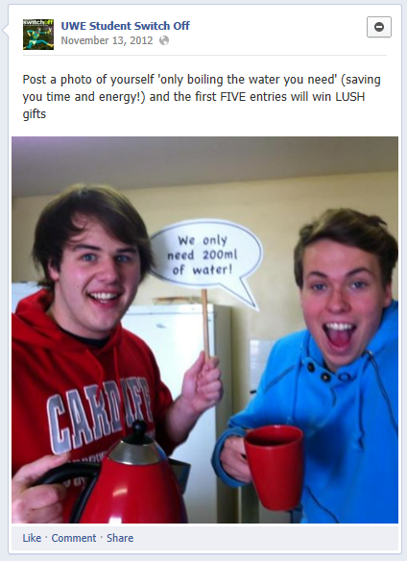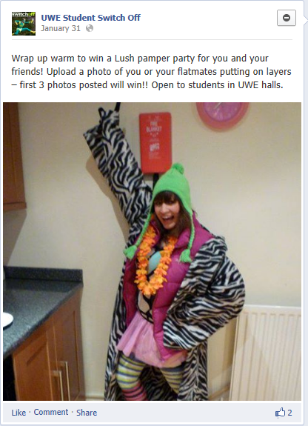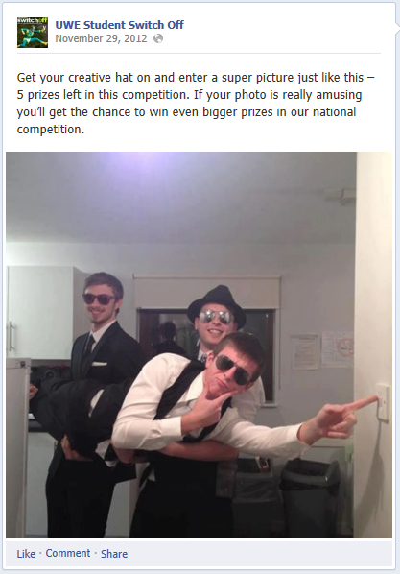
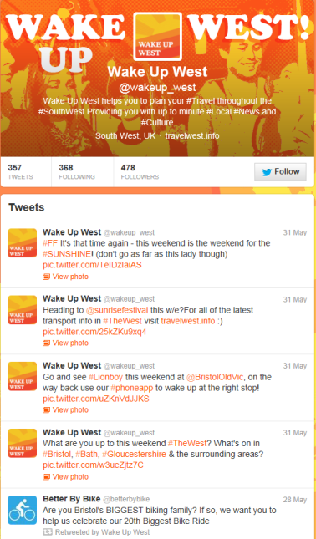
Images taken from the UWE Facebook energy page which has launched a series of photo competitions

The University of Bristol has been making good use of twitter, and although in early days for a dedicated travel feed, they have seen good success from the use of twitter for open days. Also shown is an image of the Wake Up West Twitter feed, which is a good example of a travel Twitter feed aimed at a specifically younger audience. The tone of voice is more informal and colloquial (not what you might expect from a local council feed) and there are lots of sign-posts to other events and feeds, whilst still promoting the travel message.
It is not yet clear whether it is wise to combine messages around a travel channel or to develop dedicated cycling channels. Other tools available for the local area are journey planners (TravelWest Journey Planner, Cycle Streets etc) and a council sponsored bus checker app. Both universities have moved or are moving to electronic only welcome packs and messages – these can amount to hundreds of pages of content, where messages can get lost. There may be scope to send direct emails to prospective students with a travel message (ie ‘most students in your halls bring a bike to uni, have you thought about bringing yours?’). However, it is noted that UWE accommodation services alone send upwards of 12 separate emails to new students before they arrive.

Segmentation
It is anticipated that there will not be a homogenous ‘student culture’ but multiple complex sub-groups. Differences not only between students of the two universities, but within the student body of each university (ie domestic vs international, creative/arts vs science/engineering & socio-economic background) is likely to have big impacts on the content and delivery of any intervention. Therefore segmentation and demographics need to be considered in the design of the research and project implementation.
During a campaign to reduce smoking in young adults in California, it was recognised that a social group defined as ‘hipsters’ were significantly more likely to smoke (Ling et al, 2008). This led to the resulting campaign being focused on values deemed important to the hipster sub-group of social justice and distrust of large corporations, rather than the conventional health messages. The content delivery used local artists to create compelling posters for local events in bars, where anti-tobacco messages were delivered in an authentic and effective manner (French et al, 2011).
From a travel perspective, a study on cycling/motoring segments (Anable, 2005) based on psychological values revealed some important insights into different mentalities. The segments were;
- Malcontented Motorists
- Complacent Car Addicts
- Aspiring Environmentalists
- Die Hard Drivers
- Non car owning Car-less Crusaders
- Reluctant Riders
Similar segments were derived from Leonard et al (2011), and clearly differing groups will have differing motivations and barriers. Tapp (2008) suggests there will be better returns by focusing efforts on Malcontented Motorists rather than Die Hard Drivers for instance.

Influencing and Communicating – further research
Where do students get their information from for; a) Day to day travel info? b) initial info to determine route and mode choices
Communication mode – online (web pages, social media, route planners, apps), handouts, face-to-face (peers vs uni officials).
Is this info sought out actively or delivered passively
What messages are more likely to succeed? What is the best tone of message (informal vs formal, creative, fun, linked to other aspects of student life ie going down the pub)?
How to segment the population? Are different messages needed for different segments? Who are the influencers/group leaders etc?

References
Anable, J., 2005, Complacent Car Addicts or Aspiring Environmentalists? Identifying travel behaviour segments using attitude theory, Transport Policy 12 65-78

Bartle, C., Avineri, E. and Chatterjee, K. (2011) Information-sharing, community-building and trust: A case study amongst commuter cyclists. In: 43rd Universities Transport Study Group Conference, Milton Keynes, UK, 5th-7th January, 2011
Bas Verplanken, Henk Aarts, Ad Van Knippenberg, Habit, information acquisition, and the process of making travel mode choices. European Journal of Social Psychology. Volume 27, Issue 5, pages 539–560, September/October 1997
Brog, W., Erhard, E., and Mense, N., 2002, Individualised Marketing: Changing travel behaviour for a better environment, paper at OECD Workshop: Environmentally Sustainable Transport, Berlin, 5th Dec.

Bird, Sara – Update literature review on school based interventions to delay uptake of driving licence. 2013

Behavioural Insights Toolkit, (2011) Department for Transport. https://www.gov.uk/government/uploads/system/uploads/attachment_data/file/3226/toolkit.pdf
Chatterjee, K. , Sherwin, H. , Jain, J. , Christensen, J. and Marsh,S. (2013) A conceptual model to explain turning points in travel behaviour: Application to bicycle use. To be published in Transportation Research Record. ISSN 0361-1981

Daley, M. and Rissel, C. (2011), “Perspectives and images of cycling as a barrier or facilitator of cycling”, Transport Policy, Vol. 18 No. 1, pp. 211-16.

Deutsch, M., & Gerard, H. B. (1955). A study of normative and informational social influences upon individual judgment. The Journal of Abnormal and Social Psychology, 51(3), 629-636.

Mackay, David. (2008) Sustainable Energy – Without the Hot Air

McKay, M. P., & Coben, J. H. (2002). Attitudes of novice teen drivers and their parents about Pennsylvania’s graduated driver licensing program: A focus group analysis. Traffic Injury Prevention, 3(4), 257–261. French, J., Merritt, R. & Reynolds, L. (2011). Social Marketing Casebook. Sage Publications

Heinen, E., Van Wee, B., Maat, K., 2010. Bicycle use for commuting: a literature review. Transport Reviews 30, 105–132.
HENK AARTS1 AND AP DIJKSTERHUIS2, THE AUTOMATIC ACTIVATION OF GOAL-DIRECTED BEHAVIOUR: THE CASE OF TRAVEL HABIT, Journal of Environmental Psychology (2000) 20, 75^82

Jessor, R. (1982), Problem Behavior and Developmental Transition in Adolescence. Journal of School Health, 52: 295–300. doi: 10.1111/j.1746-1561.1982.tb04626.x

Sara B Johnson, SB. & Jones, V. Adolescent development and risk of injury: using developmental science to improve interventions, nj Prev 2011;17:50-54 doi:10.1136/ip.2010.028126
Kenyon, S. and Lyons, G. (2003) The value of integrated multimodal traveller information and its potential contribution to modal change. Transportation Research Part F Traﬃc Psychology and Behaviour, 6(1). pp. 1-21. ISSN 1369-8478
Leonard, S., Spotswood, F. and Tapp, A. (2011) Understanding the self-image incongruency of British non-cyclists: implications for social marketing. In: The 2nd World Non-Profit and Social Marketing Conference, Dublin, Ireland, 11-12 April 2011
Ling, P.M., Neiland, T.B. and Glantz, S.A. (2008). Using Psychographic segmentation to identify high risk young adult smokers. FAMRI annual Scientific Symposium, Boston 10-14 May
Molin, Eric J & Timmermans, Harry J P. (2003) Testing hierarchical information integration theory: the causal structure of household residential satisfaction. volume 35(1) pages 43 – 58. Environment and Planning
Ouellette, J. A. & W. Wood (1998). Habit and Intention in Everyday Life: The Multiple Processes by Which Past Behavior. Predicts Future Behavior. Psychology Bulletin, 124(1), 54-74
Pucher, J. and Buehler, R., 2007, At the frontiers of cycling: Policy Innovations in the Netherlands, Denmark and Germany, World Transport Policy and Practice, December

Rissel C, Garrard J. Cycling for active transport and recreation in Australia. World Transport Policy & Practice. Volume 13.1 September 2006
Rousseau, D. M., Sitkin, S. B., Burt, R. S., & Camerer, C. (1998). Not so different after all: A cross-discipline view of trust. Academy of Management Review, 23, 393– 404
Sirgy, M.J., Grewal, D., Mangleburg, T.F., Park, J., Chon, K.S., Claiborne, C.B., Johar, J.S. and Berkman, H. (1997), “Assessing the predictive validity of two methods of measuring self-image congruence”, Journal of the Academy of Marketing Science, Vol. 25 No. 3, pp. 229-41.

SKINNER, D. & ROSEN, P. (2007) Hell is other Cyclists : Rethinking Transport and Identity. IN
Sloman et al (2010) The Effects of Smarter Choice Programmes in the Sustainable Travel Towns: Summary Report, http://www.dft.gov.uk/pgr...mmes/pdf/summaryreport.pdf
Stanbridge, K. and Lyons, G. (2006) Travel behaviour considerations during the process of residential relocation. In: 11th International Conference on Travel Behaviour Research, Kyoto, Japan, 16-20 August 2006
Tapp, A. 2008 Social Marketing and Cycling What Works & What Might Work - A Short Report for Bristol Cycling City. Bristol Social Marketing Centre UWE

Thorgersen, J., 2006, Social Marketing of Alternative Transportation Modes, ch23 in Garling, T. and Steg, L., Threats to the quality of life from car traffic: Problems, causes and solutions, Elsevier.
Tversky, A. & Kahneman, D. The Journal of Business, Vol. 59, No. 4, Part 2: The Behavioral Foundations of Economic Theory. (Oct., 1986), pp. S251-S278.
Web Ref 1 - http://www.ons.gov.uk/ons/guide-method/census/2011/index.html, July 2013
Web Ref 2 - www.copenhagenize.com/2009/07/worlds-most-bicycle-friendly-cities.html, July 2013
Web Ref 3 - http://www.sustrans.org.uk/blog/why-women-dont-cycle, July 2013
Web Ref 4 - TFL (2008) Attitudes to cycling. tfl.gov.uk/assets/downloads/attitudes-to-walking-2008-research-report.pdf

