Ashley Down Station

Engagement Report

March 2021

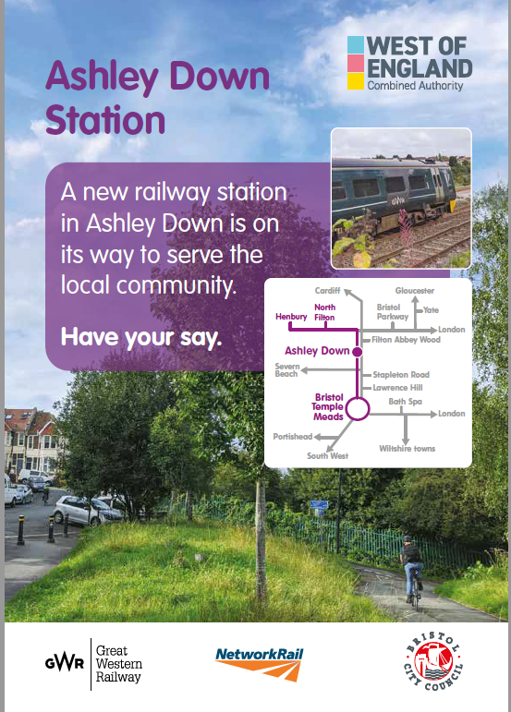
Contents
1. Summary 3
2. Background 4
2.1 Proposed designs 5
2.2 Objectives of engagement and communication 6
3. Engagement Tools 8
3.1 Community Survey 9
3.1.1 Supporting Communications 9
4. How we engaged 11
4.1 Walkabout tours 11
4.2 Less heard communities 11
5. Results summary 12
5.1 Stakeholder feedback 12
5.2 Public feedback 13
5.2.1 Online engagement 13
5.2.2 Community survey responses 15
5.2.3 Responses by question 17
5.2.4 Survey demographics and equalities analysis 31
5.2.4 Emails and phone calls 38
6. Appendices 39
6.1 Project information 39
6.2 Supporting materials 45
6.2.1 Maps and plans 45
6.2.2 Computer-aided Design images and animation produced by Network Rail 49
6.2.3 Social media post 50
6.2.4 Postcard 50
6.2.5 Poster 51
6.2.6 Vinyl banner 51
6.2.7 Booklet 52
6.2.8 Survey 55
6.2.9 Social media schedule 58
6.3 Social media engagement statistics 64
6.4 Stakeholder responses 65

Summary
Between 21st September and 1st November 2020 Bristol City Council in partnership with West of England Combined Authority (WECA) conducted public engagement to introduce and gain feedback on the most recent proposed designs for access to the upcoming Ashley Down Rail Station whilst informing on known aspects of the design of the station itself. This is part of the MetroWest Phase 2 project to deliver new and more frequent rail services across the region.

How we engaged
As this engagement process was taking place during the COVID-19 pandemic there were certain restrictions that applied which meant our face to face engagement had to be limited. The team had planned to carry out door-knocking to local residents where people would have been given an outline of the project and given a paper copy of the survey or asked if they would like to fill it via an iPad. However, the team adapted the approach below to ensure the information and survey reached as wide an audience as possible, the team did the following:
- Travelwest webpages included the background information on the project, Frequently Asked Questions, and the community survey, as well as a web contact form to contact the team and order a paper copy of the survey and project information
- Online community survey hosted and accessed via the Travelwest website
- Paper booklet that was the offline version of the information presented online, community survey and map (this was also available in different formats on request for example, easy read, braille and language translations)
- Organised pre-bookable ‘walkabout tours’ of the area covered by the proposed design on Concorde Way to walk people through the proposed design, whilst adhering to current COVID-19 restrictions and keep staff and attendees safe
- Offered virtual meetings, phone appointments that were advertised on the products
- Postcards were created for direct mail purposes, sent to 5800 households locally
- Vinyl banners displayed on Concorde Way
- Posters put up on local community noticeboards, education centres, local shops and businesses and on street and Concorde Way
- Social media posts
- Information about the survey was displayed at local bus stops on Ashley Down Road, Muller Road and Shaldon Rd for the duration of the survey using the Real Time Information digital screens
- Emails sent to stakeholders
- Responded to enquiries by post, email and phone call.

Over 179 stakeholders and local businesses were engaged, with 457 responses to the community survey from the stakeholders, businesses, and the public, and 41 enquiries by emails and phone.
Main concerns raised that respondents to the community survey anticipated experiencing on their journey to the new railway station (number of responses, followed by % of total responses to survey):
- There is not enough parking – 141 responses, 30.9%
- The street is busy with traffic – 116 responses, 25.4%
- No adequate secure cycle parking to leave a bicycle overnight – 115 responses, 25.2%

Of the 291 comments that were made by respondents to the survey about the design for access to Ashley Down Station (number of responses, followed by % of total respondents to the survey):
- Keep path by steps (Station Road to underpass) – 24 responses, (5.2% of total responses to survey)
- Secure and covered cycle parking – 21 responses, (4.6% of total responses to survey)
Further comments and suggestions made relating to Ashley Down Station:
- Requesting Residents Parking scheme to mitigate perceived influx of those parking to use the new railway station – 72 responses (16% of total responses to survey)
- Car park for Station (for example locating it on Station Lane) – 21 responses, (4.6% of total responses to survey)

Background
The new station at Ashley Down is part of a project to re-open the Henbury Line that runs from Bristol Temple Meads to Henbury. The new Ashley Down Rail Station is located on the site of the previous Ashley Hill Station. Its location makes it easily accessible for people living locally.
It is part of the West of England Combined Authority’s plans to significantly increase travel by rail and improve air quality in the region, as part of MetroWest Phase 2. Working towards Bristol City Council’s commitment to be a carbon neutral and climate resilient city by 2030 and strategic goal as part of the One City Transport Board for transport that is efficient, sustainable and inclusive by 2050.
The Joint Local Transport Plan 4 (JLTP4) - led by the West of England Combined Authority, working with Bath and North East Somerset, Bristol, North Somerset and South Gloucestershire councils – looks at transport up to 2036. It aims to set out how to achieve a well-connected sustainable transport network that works for residents, businesses and visitors across the region; a network that offers greater, realistic travel choices and makes walking, cycling and public transport the natural way to travel.
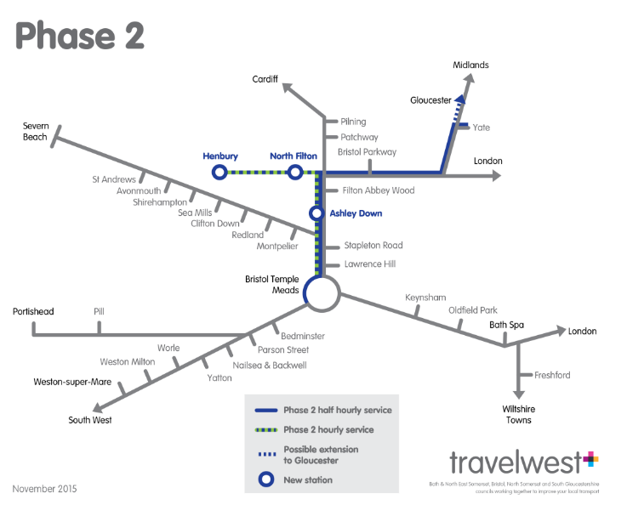
MetroWest Phase 2 is identified as a Major Scheme within the Joint Local Transport Plan 4, noted as Scheme C4. Ashley Down station is mentioned a specific intervention within MetroWest Phase 2.
The proposed station at Ashley Down will increase the community’s connectivity to the wider train network through to Bristol Parkway and Temple Meads and then further afield to London, Wales, the Midlands and the South West of England.
The opening date of Ashley Down Rail Station is likely to be in 2023 and we are working with Network Rail who are building the station itself, to refine this date. The opening date is also dependent on the tender process and contractor programme.

2.1 Proposed designs
Highway works and improvements to pedestrian/cycle access in the vicinity, on Station Road, are considered necessary to support the new rail station at Ashley Down and provide an Equality Act (EqA) compliant access.
The proposals for the station also include improvements to pedestrian and cycle access on Station Road, enhanced planting, an entrance point for cyclists and two new accessible parking bays.
The station entrance will be located on Concorde Way where the path meets Station Road in Ashley Down, Bristol. The route to the station from Muller Road and Station Lane, will be via the existing subway footway. This gives access to the entrance on Station Road/Concorde Way.
To ensure the station can be used by all members of our community and to meet Equality Act compliance, the new station at Ashley Down must have accessible access. In accordance with national standards, a ‘1 in 20’ gradient path is proposed to enable access from the accessible parking bays to the station entrance.
See Appendix 6.1 for further Project Information, including Frequently Asked Questions.
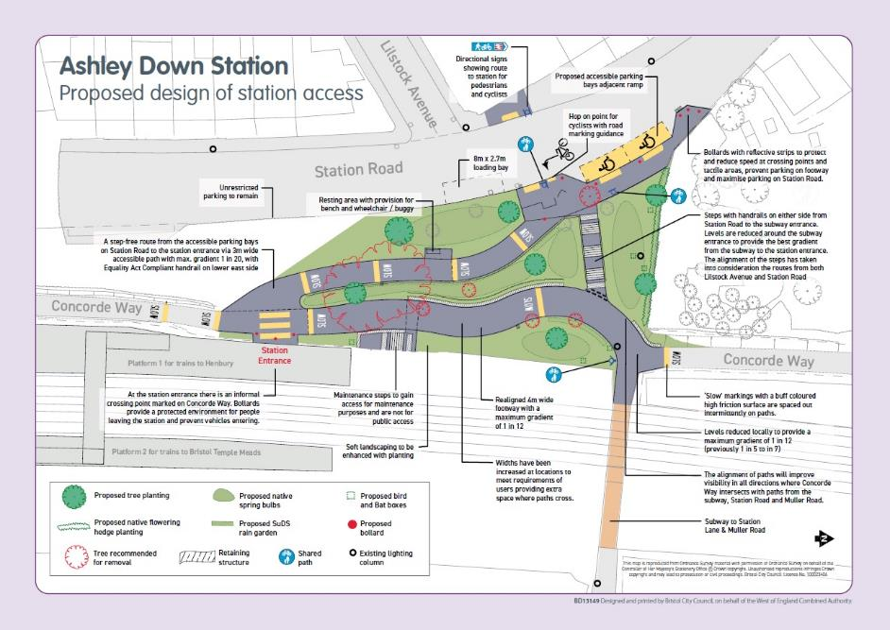
Figure 1: ‘Easy read’ version of the proposed design for the access to Ashley Down Station

2.2 Objectives of engagement and communication
Engagement with local people and those who travel along Concorde Way began on 21st September 2020 and finished 1st November 2020.
The main aims of the engagement exercise were:
- To explain the scope and objectives of the wider MetroWest project, as part of the region’s plans to significantly increase travel by rail in the region generating over a million new rail journeys.
- To clearly set out that this engagement is about designing the access to the station and informing of the design of the station.
- To seek views from Strategic and local stakeholders at an early stage on the proposed design for access improvements to the new station and offer a chance to raise issues and concerns to inform the final design.
- To seek views from local people living and working locally, future users of the Henbury Line, and businesses, at an early stage to inform the final design of the access to the station to listen to any concerns that may enable us to improve the proposals in advance of formal consultation on Traffic Regulation Orders.
- To begin a constructive dialogue and create the environment where people can be involved throughout the process of design and implementation.
- To create a good understanding of the scheme and its benefits amongst stakeholders, local businesses, local people and commuters.
- To demonstrate Bristol City Council is prioritising sustainable transport options to help Bristol become a sustainable city with a low impact on our planet and a healthy environment for all.

In order to achieve these objectives, the team agreed upon key messages such as:
- The proposed new station at Ashley Down is part of a project to re-open the Henbury Line going from Temple Meads to Henbury. It is part of part of the West of England Combined Authority’s plans to significantly increase travel by rail and improve air quality in the region.
- The new rail station is being designed as a community station - making it easier for local people to use the train and connect with the wider transport network. We are sharing proposed designs for how people will be able to access the station and we’d like your views about certain elements of the design that may enable us to improve the proposals ahead of any formal consultation.
- We want to inform you on Network Rail’s design of the station, which has been designed to meet the required rail industry standards at the site of which is included in the Local Plan and, given its location, this can’t be changed.
- All new stations on the route will be compliant with Equality Act accessibility requirements and have appropriate bus stops, including at Ashley Down Station. Station Road entrance will have accessible access, a subway footway from Station Lane allows pedestrians to access the entrance on Station Road/Concorde Way from the Muller Roadside.
- We want to encourage walking and cycling to the station – we want to hear your views on how to make this easy for you to do.
- There will be accessible parking provided for Blue Badge holders. There is no general car parking provision associated with the new station.
- This is a long-term project – we recognise that train travel at the current time is restricted due to the coronavirus pandemic, but the plans are being drawn up now to make transport around the city more sustainable in the long term.
- The station will connect local people to jobs and leisure opportunities including at the South Gloucestershire Cricket Club and Bristol County Ground, the Memorial Stadium and to the future Bristol Arena site in Filton.
- The station will provide key routes for connecting to the wider train network through to Bristol Parkway and Temple Meads and then further afield to London, Wales, the Midlands and the South West of England.
The target audiences for this project include stakeholders who were made aware of the engagement exercise and invited to make comments, such as:
- Ward members and the local MP
- Transport operators
- Network Rail - key partner
- Sustrans – owners of Concorde Way land immediately outside the station, custodians of National Cycle Network
- Rail interest groups such as Friends of Suburban Railways
- Cycle forum / groups - Bristol Cycling Campaign
- Walking groups – Bristol Walking Alliance
- Bristol Tree Forum
- Taxi operators - Taxis Forum / Taxis officer
- Equalities forum – Bristol Physical Access Chain
- Equalities and VCSE groups
- Hospitals
- Schools
- Bristol One City Transport Board
- Internal stakeholders/project teams
- Local businesses
- Business West
- Bristol Property Agents Association
- South Gloucestershire Cricket Club
- Memorial Stadium
The other target audiences are the transport users themselves such as:
- Local people who live on side roads either side of the railway line or who might be impacted by the new station
- Commuters on the route
- Train users
- Bus users
- Area committees, such as Bishopston, Cotham and Redland Community Partnership
- Local groups
- Shops / business on the route

Engagement Tools
Due to the Coronavirus pandemic, the way in which we would ordinarily engage has had to be reimagined. The restrictions on face to face engagement due to the lockdown and people shielding has meant the team has had to think about the different ways to engage with people.
The team would ordinarily have set up workshops and events to capture thoughts on maps and plans where people could explain their issues and discuss their ideas. Instead a survey was created to ensure we could record information from people about their general thoughts and ideas about the access to the station.
Therefore, the team created a range of tools to be used for the project to convey information and record comments and suggestions during the engagement. These included:
- Travelwest webpages included the background information on the project, Frequently Asked Questions, and links to the survey, as well as a web contact form to contact the team and order a paper copy of the survey and project information
- Online survey hosted and accessed via the Travelwest website
- Paper booklet that was the offline version of the exhibition, survey and map (this was also available in different formats on request such as easy read, translations, braille etc)
- Organised site tours of the area covered by the proposed design on Concorde Way to walk people through the proposed design
- Attended virtual meetings
- Postcards were created and posted directly to residents
- Vinyl banners displayed on Concorde Way
- Posters put up on local community noticeboards, education centres, local shops and businesses and on street
- Social media posts
- Information on bus stops using the Real Time Information digital screens.

3.1 Community Survey
The survey was designed based on the Healthy Streets approach and was structured as follows:
- 8 Questions describing the respondent in terms of who they are and travel habits, including whether they intended to use the new station and which side they would approach from.
- 3 Questions about the key elements of the proposed design for the access to the station, and the wider public realm in association with the station, concerns and suggestions for improvements. This included free text boxes to voice concerns and make suggestions for improvements.
- About you section to capture demographic and equalities data
- Contact preferences if individuals wanted to be informed of progress on this project and future engagements / consultations

Paper copies of the survey were sent out with an accompanying booklet and freepost envelope to return the completed survey. The deadline for paper copy responses was set 1 week before the online survey closed.

See Appendix 6.2 for Ashley Down Station Booklet and Community survey to see the paper version of the survey which reflects the online version of the survey.

3.1.1 Supporting Communications
An easy-read version of the technical design plan was created, along with maps of the station location and a network map which included the proposed new station on the Henbury line.
Network Rail created computer-aided design (CAD) images and an animated tour that envisioned what the journey to access the station would look like from Station Road was uploaded to the Travelwest YouTube channel. The images were used in the booklet and both images and video were embedded on the webpage alongside project information.
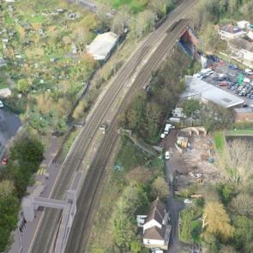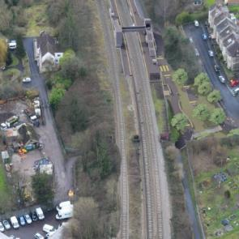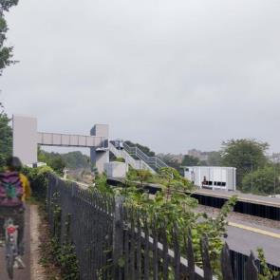
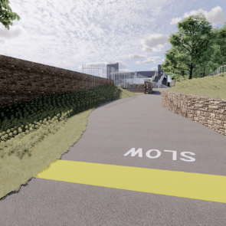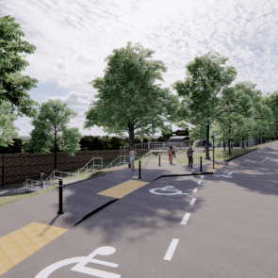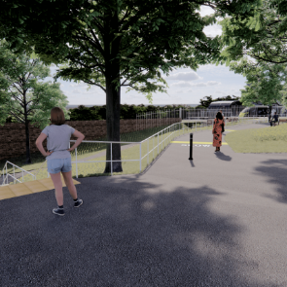
To ensure we heard from all communities 5800 postcards were sent to all households and businesses in the wider area (yellow area as shown on the map below). This was to let them know the engagement had started with the opportunity to have their say on the latest proposed design for the access to the station. It included a link to the webpage and contact details if paper copies were required or further information required.
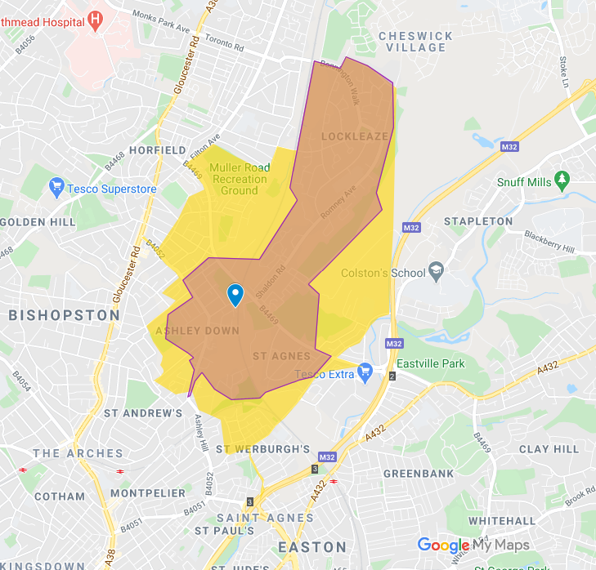
Information booklets with accompanying survey and freepost envelope were delivered to 3,000 local residents and businesses (orange area on map).
Posters were placed on community noticeboards, along Concorde Way and offered to local businesses, education centres and community groups to display, along with 2 vinyl banners which included the proposed design plan, maps and links to the webpage and survey, and contact details for the project team.
Social media posts were scheduled from the Travelwest channels which were amplified via, WECA, BCC social media accounts.
See Appendix 6.2 for all supporting communications materials and social media schedule as described above.
A short message was programmed to display on the Real Time Information digital screens at nearby bus stops on Ashley Down Road, Muller Road, Shaldon Rd for the duration of the survey.
The team also created a press release which was sent out to journalists from WECA.

How we engaged
Emails to local councillors and MPs were sent in advance of the survey going live, to let them know of the intention to engage and asking for advice and local knowledge of stakeholders to include.
An email to stakeholders including councillors and MPs, was sent once the webpages and survey went live and included a digital postcard to share with their networks.
By engaging with local residents, at least 3 local WhatsApp groups shared the information about the survey with their network:
- Ashley Vale Allotments
- Ashley Down Mutual Aid
- York Avenue Residents
It was also circulated via a well-used email mailing list sent by residents of The Yard in St Werburghs.
There were regular social media posts from both the Travelwest Twitter and Facebook accounts. These social media posts were also promoted by the WECA, Bristol City Council, and other transport social media accounts.

4.1 Walkabout tours
Walkabouts tours of the site on Concorde Way were organised following COVID-19-secure measures, in order to guide people through the proposed design for the access to the station, and inform them of known designs of the station itself, and signpost them to feedback through the survey. In total, 5 tours were organised on Tuesday 13th October 2020. Each tour provided 5 pre-booked places in order to adhere by COVID-19 restrictions and keep staff and attendees safe. These were advertised through the engagement email sent to stakeholders as well as on the project webpage.
All the 20 places were fully booked by the day before the tours. However, only 15 people attended in total, of these 4 were walk ups or came in the place of a neighbour, 8 people were no shows or cancelled after 6pm the day before which meant the team did not have time to reallocate places to the waiting list.

4.2 Less heard communities
Traditionally the younger population, those from ethnic minority groups and those living in the most deprived wards are often less heard from in local government engagement exercises. So to ensure we gave those communities the chance to get involved we delivered 3000 paper copies of the survey and map in the form of the booklet to all of the households in those areas. Using the indices of national deprivation and ward profiles, it was agreed in terms of deprivation to widen the area of engagement into the northern part of Lockleaze, posting postcards to residents and businesses and delivering booklet packs.
In pre-COVID-19 times we would have followed these up with targeted door knocking in these wards and interview surveys at selected areas where footfall is particularly high such as on Concorde Way, at the local supermarkets on Muller Rd, and Fairfield High School. If events had been allowed the plan was to book events at these suggested locations and present a paper-based version of the proposed landscape plan asking people to put coloured dots on the map grouping their issues or ideas for improvements in different colours or workshop how they would redesign the access paths to the station using models and props. We were able to provide a large-scale map for people to view before and after the tours.
On all the paper and online copies of the engagement outputs the team provided a phone number which had an answerphone function. People could call and leave a message asking a question or leaving a comment and someone would get back to them. An email address was also provided along with a written address, so people had a choice of how they wished to communicate.

Results summary

5.1 Stakeholder feedback
The team identified 179 stakeholders and put these into two categories: strategic and local stakeholders. The strategic stakeholders were defined by those who were most closely connected or affected by the project. Local stakeholders were defined by those represented groups /members in different sectors of community and who had influence and reach to comment and help spread the word of the engagement.
Strategic Stakeholders
The team sent 73 emails once the engagement process had started to strategic stakeholders that included representatives of the emergency services, One City Transport board, elected officials such as MPs, Cabinet Members and ward members, internal stakeholders, environmental groups and equality groups with a citywide view. The email detailed the project and asked for input into the engagement process and offered a meeting or discussion to talk through the project, provided a link to book on to a tour and asked them to use the social media post to help increase the reach of the engagement.
One local councillor and two organisations engaged with the team over email.
Local Stakeholders
The team also sent 70 emails to local stakeholders, those without an email address were sent a postcard and booklet pack. These included education representatives of schools and colleges, local businesses, community and faith groups, allotment associations and sports clubs. The email detailed the project and asked for input into the engagement process and offered a meeting or discussion to talk through the project, provided a link to book on to a tour and asked them to use the social media post to help increase the reach of the engagement. Other organisations that have been briefed include Bristol Physical Access Chain who had been involved before prosed designs were drawn up to help guide on access for those with disabilities.
Examples of responses from local stakeholders summarised as follows:
Bristol Physical Access Chain (BPAC)
BPAC offered specific advice on design elements of the proposal when they met with the Project team in April 2020 to show disabled people that the rail service was available to them. These included a dropped kerb, and tactile paving on the approaches to the Station, Blue badge holder parking bays, reducing the slope, lighting, and recommending replacing the existing bench with one that is higher and has armrests. BPAC also extended their assistance and advice to Network Rail to make some recommendations to help disabled people have a good access around the station.
Bristol Cycling Campaign
Bristol Cycling Campaign welcomed the proposal to reduce the gradient on the section of Concorde Way adjacent to Station Lane subway, which will help improve the desirability, safety, and accessibility of the route. They fully support the plan to include covered CCTV monitored cycle parking spaces within the station and raised concerns about conflict between cyclists and pedestrians around the station entrance, calling for improvements to Concorde Way due to congestion including widening the path to achieve fully segregated provision in accordance with LTN 1/20 (Government guidance for Local Authorities on designing high quality, safe cycling infrastructure) which will improve the route for all users.
Bristol Cycling Campaign also suggested we include the following question: Would you leave your bicycle parked overnight at or near the station?
BCR Street scene (part of the Bishopston and Ashley Down, Cotham and Redland Community Partnership)
The group are concerned about illegal graffiti and recommended design elements such replacing masonry surfaces with greenery to reduce maintenance and to prevent an area which generates a fear of safety and crime associated with graffiti and nuisance tagging.
Fairfield High School
The Principal commented that the school is totally in favour of the proposed design and implementation of the new station at Ashley Down as it will help staff travel sustainably to work. They would like to see improvements of the underpass for walking and cycling.
See Appendix 6.4 for full Stakeholder responses.

5.2 Public feedback
Below details the response to the survey and emails/ phone calls received. The number of comments received totalled 498 which was made up of 457 survey responses, 41 emails/phone calls, including 2 call-backs requested. In addition, there were also 36 requests for booklets packs made via webform, email and phone calls.

The team are happy with this response rate considering this engagement was carried out during COVID-19 restrictions which meant we were limited on our engagement methods. The number of responses received for this survey are broadly similar to other transport engagement surveys we have run. Also, at the same time Bristol City Council launched the Bristol Bridge bus gate, pedestrianisation of the Old City and the other walking and cycling improvement schemes which also required engagement with the public and stakeholders.

Online engagement
Webpage
- A total of 3500 users visited the page, generating a total of 4200 unique pageviews and 4100 sessions (a session is a period of time a user is actively engaged with the webpage)
- The channel that generated the most sessions was social media with a total of 1900 (Facebook accounted for 1800 of these); followed by direct engagement with the webpage with a total of 1400
- The technical drawing of the design PDF was downloaded 146 times
- Frequently Asked Question (FAQs) were accessed 4700 times, the most popular and number of views were:
  - When is the station likely to open? – 303 views
  - Where is the new Ashley Down Rail Station going to be? – 275 views
  - Where can I go from this new station? – 268 views
  - Is there an entrance from Station Lane (Muller Rd side) if not, why not? – 253 views
  - How often will the trains run? – 250 views
- The YouTube video on the page was started 587 times, and watched until the end 469 times
- Other links, including on page, were followed 361 times, the most popular were:
  - Click here if you’d like to know more about the MetroWest initiative: https://travelwest.info/metrowest - 100 clicks
  - MetroWest phase 2: https://travelwest.info/projects/metrowest/metrowest-phase-2 - 61 clicks
  - click outbound: ashleydownstationproposedlandscapedesigntour.eventbrite.co.uk -25 clicks

Social media
- 5 Facebook posts had a total reach of 373, with a total of 4 link clicks, 1 like and 18 video views. Total engagement rate was 1.38%
- 13 Tweets were viewed 16,908 times, with a total of 184 link clicks, 28 retweets, 261 media views and 15 likes. Total engagement rate was 3.95%
See Appendix 6.2.9 for Social media engagement reports

Mailing list
A total of 71 contacts registered for the MetroWest mailing list since the form was added onto the Travelwest website. Unfortunately, it is not possible to say how many came from the main MetroWest page or the Ashley Down Station submission confirmation page, as this all uses the same Mailchimp Application Programming Interface (API).
In terms of who registered interest for each subject, also an email was sent to all existing MetroWest subscribers saying that they had new options to choose from to subscribe, which means that the numbers below may not match the number of new subscribers:
- Ashley Down Station only: 88 contacts
- Henbury line: 154 contacts
- MetroWest – the wider project: 1502 contacts
Total subscribers to the MetroWest mailing list: 1557

5.2.2 Community survey responses
A total of 457 responses to the survey were received over the engagement period.

Pin indicates Ashley Down Station location, with green polygon representing the area covered by the proposed design.

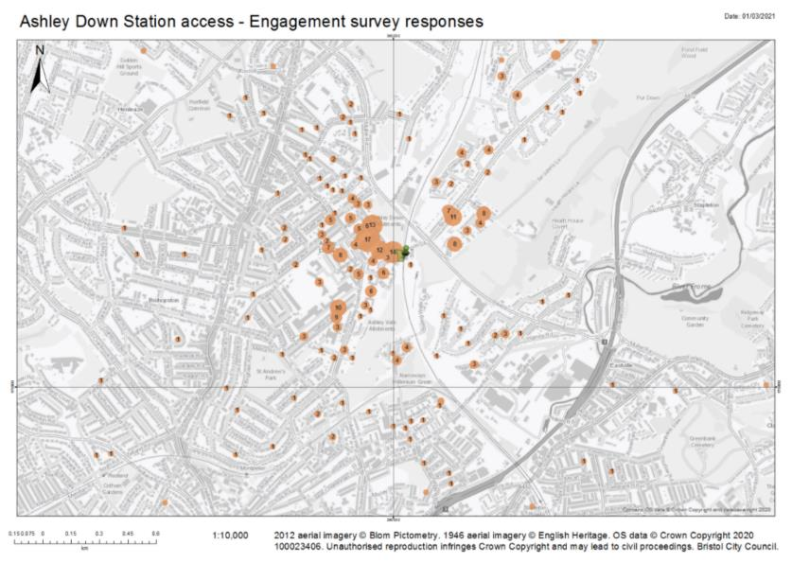
Figure 2: Map of responses to the community survey received from each postcode.
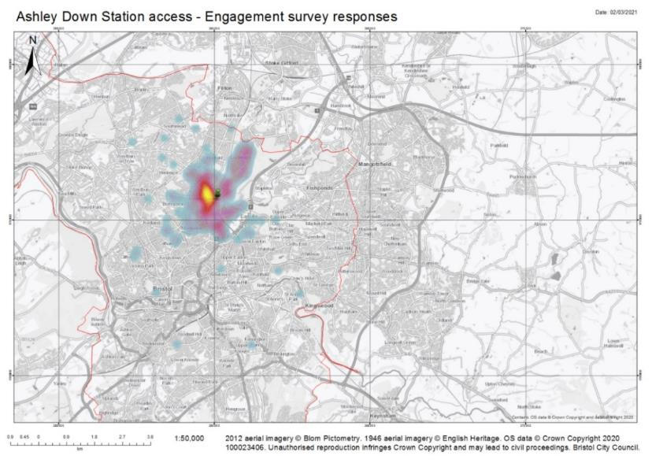
Figure 3: Heat map on responses to the community survey

Ward | Number of responses from each Ward | % of those who left postcode (406) | % of respondents to survey (457)
Ashley | 48 | 11.8% | 11%
Bishopston and Ashley Down | 197 | 48.5% | 43.1%
Brislington East | 1 | 0.2% | 0.2%
Brislington West | 1 | 0.2% | 0.2%
Clifton Down | 2 | 0.5% | 0.4%
Cotham | 3 | 0.7% | 0.7%
Easton | 2 | 0.5% | 0.4%
Eastville | 3 | 0.7% | 0.7%
Horfield | 5 | 1.2% | 1.1%
Hotwells and Harbourside | 1 | 0.2% | 0.2%
Lawrence Hill | 2 | 0.5% | 0.4%
Lockleaze | 115 | 28.3% | 25.2%
Redland | 7 | 1.7% | 1.5%
Severn Vale, S. Gloucestershire | 1 | 0.2% | 0.2%
Southmead | 2 | 0.5% | 0.4%
St George West | 1 | 0.2% | 0.2%
St. Christopher's, Monmouthshire | 1 | 0.2% | 0.2%
Westbury-on-Trym and Henleaze | 4 | 1.0% | 0.9%
Windmill Hill | 1 | 0.2% | 0.2%

- 406 of 457 people left their postcodes in order that we could map responses, of these 395 were able to be mapped
- The highest numbers of responses came from the wards which the site is in (Bishopston and Ashley Down) and its neighbouring ward, Lockleaze
- 2 responses came from beyond the City of Bristol (South Gloucestershire and Monmouthshire)
- Online responses: 262 (57%)
- Paper copy responses: 195 (43%)
- Return rate of paper surveys is 6.5%, this is double the average of 2-3%, due to targeted local delivery of paper copy surveys for this local transport project.

5.2.3 Responses by question
This section covers a summary for each question with the headline findings and breakdown of responses:
Which of the following best describes you?

Which of the following best describes you? | Number of responses | % of respondents to survey (457)
I am a resident in Bristol | 377 | 82.5%
I live locally to the new rail station | 359 | 78.6%
I live elsewhere | 5 | 1.1%
I am a local business owner | 8 | 1.8%
I work near the new rail station | 26 | 5.7%
I am a bus user travelling near the new rail station | 45 | 9.8%
I am a cyclist who uses Concorde Way | 180 | 39.4%
I am a pedestrian who uses Concorde Way | 210 | 46.0%
I am a car driver using a route near the new rail station | 123 | 26.9%
I am a taxi / private hire driver | 0 | 0.0%
I am a trades person working frequently in the area near the new rail station | 2 | 0.4%
I am a regular visitor to the area | 49 | 10.7%
I am responding on behalf of a Voluntary Group / Community Group / Social Enterprise | 1 | 0.2%
Other | 9 | 2.0%
Response rate: 90%
- 6 responses from local business owners
- One response on behalf of a Voluntary Group / Community Group / Social Enterprise – BCR Street scene (part of the Bishopston and Ashley Down, Cotham and Redland Community Partnership) who’s comments are included in local stakeholder feedback
Other responses to how respondents wanted to describe themselves as college students, having school aged children who regularly travel through the area and use Concorde Way, retired, live locally and commute by rail outside of the city.
Q1. What are the main concerns you anticipate experiencing with the street environment on your journey to the new rail station (tick all that apply)?

What are the main concerns you anticipate experiencing with the street environment on your journey to the new rail station (tick all that apply)? | Number of Responses | % of respondents to survey (457)
The streets to the new station are unpleasant/unsafe to walk along | 70 | 15%
The streets are too busy with people | 27 | 6%
The road feels unsafe to cycle on | 59 | 13%
No adequate secure cycle parking to leave a bicycle overnight | 115 | 25%
The bus timetable is not synchronised with the train timetable | 96 | 21%
The buses are unreliable | 90 | 20%
The street is busy with traffic | 116 | 25%
Concorde Way is difficult to cross | 53 | 12%
There is too much congestion | 97 | 21%
The air quality is bad | 78 | 17%
There is not enough parking | 141 | 31%
Other | 133 | 29%
Please specify: (open text field) | 121 | 27%
Response rate: 99%
Main concerns:
- 31% There is not enough parking
- 25% The street is busy with traffic
- 25% No adequate secure cycle parking to leave a bicycle overnight
Summary of other concerns specified under ‘Other concern’:
121 respondents left comments specifying ‘Other’ concerns
- 22% of those who specified an ‘other concern’, had ‘no concerns’ (6% of total respondents to the survey)
- 21% of these ‘other concerns’ mentioned car parking specifically. See below for a summary concerns raised in relation to car parking.
- Others related to personal safety, preservation of wildlife and trees, reliability of rail services, improvements to Station Lane and conflict between pedestrians and cyclists.
Other concerns | Number of comments | % of total responses to survey (457)
No concerns | 27 | 5.9%
Gradient of path or streets/access to station | 9 | 2%
Path layout | 3 | 0.7%
Conflict with pedestrians on Concorde way | 6 | 1.3%
Congestion at station entrance on Concorde Way | 2 | 0.4%
Car parking | 25 | 5.5%
Access for essential services such as emergency and waste vehicles | 1 | 0.2%
Reliability of rail service, synchronisation with mainline, connectivity | 7 | 1.5%
Keep Cycle route proposed to be made into steps - Station Rd to underpass and Muller Rd | 4 | 0.9%
Trees and wildlife | 8 | 1.8%
Crossing Muller Rd | 5 | 1.1%
Air Pollution | 3 | 0.7%
Noise Pollution | 2 | 0.4%
Litter | 1 | 0.2%
Station Lane improvements for pedestrian, cycle and by car | 6 | 1.3%
Underpass safety for example improving lighting and installing CCTV | 1 | 0.2%
Underpass improvements for example, to surface of footway | 1 | 0.2%
Personal safety - CCTV, Lighting, manned station | 8 | 1.8%
Quality of public realm | 2 | 0.4%
Station Road improvements to pedestrian environment, for example pavements | 2 | 0.4%
Not enough cycle parking | 3 | 0.7%
Road safety | 10 | 2.2%
Vandalism | 1 | 0.2%
Not enough Blue Badge bays | 1 | 0.2%
Bus links are up a steep hill or too far away | 1 | 0.2%

The majority of these ‘other concerns’ fell into two themes:
- No concerns – 27 responses, include:
- Six of these responses live within walking distance to station
Others commented:
- “looks thought through and sensible”
- “the proposed design is a vast improvement on current configuration”

- Car parking – 25 responses
- The majority of these concerns were that people using the station will drive and park in surrounding roads when station opens, making it harder for residents to park their vehicles locally.
- Six requesting Residents Parking Scheme to combat perceived increased to car parking in the area due to the station opening.
- Two concerns raised that no support will be given to combat extra parking on private roads such as Dirac Road.
- Some concerns about cars idling engines while waiting to pick up and increased air pollution of drivers looking for parking spaces
- Two safety concerns for pedestrians and cyclists due to increased traffic of those using the station.
Q2. What are the key elements of the design for the access to the new station are important to you?
Response rate: 99.6%
- 69% of total survey respondents felt ‘Elements to encourage local wildlife’ were ‘Extremely important’ (47%) or ‘Very important’ (22%).
- Even though 21% of survey respondents raised concerns about car parking in the previous question, when asked if car parking was important to them as a key element of the design for access to the new station, 44% said it was ‘Not at all important’, and 56% saying it was important in a range of ‘Extremely’ to ‘Somewhat important’, but only 37% saying it was ‘Very’ or ‘Extremely important’.

Of those who responded to the survey, 79% (359 of 457 respondents) identified as living locally to the new station, car parking was not an important element of the design of the access to the station to them personally, but they may be concerned about people living further away who will drive and park in the unrestricted parking in the nearby streets, in which these respondents to live, to use the station.
Of the 79% of respondents who describe themselves as living locally to the new rail station, 32% are concerned that ‘There is not enough parking’ in question 1. However, of these respondents 42% did not think car parking was a key element of the design for the access to the station (Question 2).
In order to ascertain what were the main elements of the design that people felt were important, responses ranging from ‘Extremely’ to ‘Somewhat Important’ were combined. When these figfures are combined the top three elements of the design for access to the station that people felt were important are:
- Reducing conflict between people walking and cycling
- Elements to encourage local wildlife
- Better lighting
NB: Car parking as a key design element ranks the lowest importance in this context. As mentioned above, 56% saying it was important in a range of ‘Extremely’ to ‘Somewhat important’, compared to 44% said it was ‘Not at all important’.
The table below shows key elements of the design that people felt were ‘important’ against those which people felt were ‘not at all important’
Key elements in order of importance | Important (sum of range from ‘Extremely’ to ‘Somewhat’) |  | Not important at all
 | No. of responses to element option | % of total respondents to the survey | No. of responses to element option | % of total respondents to the survey
Reducing conflict between people walking and cycling | 428 | 93.7% | 28 | 6.1%
Elements to encourage local wildlife | 427 | 93.4% | 29 | 6.3%
Better lighting | 419 | 91.7% | 36 | 7.9%
More visibility where routes intersect i.e. to reduce blind corners at junction of Concorde way and existing subway | 415 | 90.8% | 41 | 9.0%
More pedestrian/disability access priority | 404 | 88.4% | 52 | 11.4%
Bus arrival/departure times synchronised to meet train timetable | 400 | 87.5% | 55 | 12.0%
Direction signs and maps to the station, walking and cycling routes | 399 | 87.3% | 56 | 12.3%
Signage to slow people on bikes | 398 | 87.1% | 57 | 12.5%
More seating and rest areas | 361 | 79.0% | 94 | 20.6%
Easier to cross the road/Concorde Way | 380 | 83.2% | 76 | 16.6%
Cycle parking facilities – on street | 384 | 84.0% | 72 | 15.8%
Screening from local residences for example with trees/bushes | 377 | 82.5% | 79 | 17.3%
Traffic calming on neighbouring roads | 377 | 82.5% | 77 | 16.8%
More cycle priority | 366 | 80.1% | 89 | 19.5%
Car parking | 254 | 55.6% | 201 | 44.0%

Q3. Would you leave your bicycle parked overnight at or near the station?
This question was included as a result of early engagement with Bristol Cycling Campaign.

Response rate: 100%
Q4. Do you have any other comments or suggestions to improve the proposed design for the new rail station access?
Response rate: 61%
- 278 respondents to the survey left a comment or suggestion in the open text field provided in Question 4. Many responses included multiple suggestions across different themes and so have been considered in the themes below.
- 14% (39) of those who left a comment expressed their explicit support of the station, only 1 person who left a comment was explicitly unsupportive.

Themes of comments and suggestions (in priority order of highest received per theme):
- Parking and traffic management – 124 comments
- Relating to Proposed design of access to the station for example accessibility-related or managing path users – 90 comments
- Station design and operation – 60 comments
- Improving walking and cycling infrastructure in the wider area – 33 comments
- Facilities for example secure cycle parking – 32 comments
- Preservation of wildlife and trees – 29 comments
- Improving personal safety – 22 comments
- Community engagement – 21 comments
- Environmental pollution – 18 comments
- Local transport integration – 13 comments

- Parking and traffic management – 124 comments | - 72 responses explicitly requested a Residents Parking Scheme in the local area to mitigate the perceived impact of station users driving and parking in the residential roads near the site for Ashley Down Station, with 3 only opposed to a Residents Parking Scheme  - 14 comments related to management of parking for example 'consider impact on local residents' or discourage people driving and parking on local roads to use the station'  - Additionally, 9 comments (also noted in Community Engagement theme below,) about providing practical/tangible encouragement to walk/cycle/bus/rail to discourage driving to station, including those travelling to local sports venues  - 21 suggested a car park for the station (for example on Station Lane), with 6 comments against any parking for the station  - 5 suggesting traffic calming measures in local roads  - 3 suggesting traffic management for match days
- Relating to Proposed design of access to the station – 90 comments | - 24 comments relate to keeping the path by steps (Station Road to underpass) or adding an additional channel to wheel bikes next to the steps  - 15 comments concerned about pinch point at crossing to station entrance over Concorde Way  - 10 comments suggest further mitigation of cyclist-pedestrian conflict for example by promoting shared use, slow cyclists, with 12 specifying segregated walking/cycling lanes, 4 suggesting more signage - shared use, directs, slow down for cyclists, 1 suggestion of a left and right lane that would be shared-use, 1 widen entrance to path from Station Road  - 6 suggestions to improve visibility on blind corners by widening the path and using convex mirrors  - 4 suggestions for a footbridge over Concorde Way from southern end of Station Road to the station  - 2 people suggested using materials to ‘design out’ opportunities for graffiti and vandalism by using less vulnerable surfaces such as green walls/ hedges and ensuring that easily cleanable surfaces are used where hedges and plant covered walls are not achievable.  - 1 person suggested further design elements to improve accessibility for disabled people: double handrail for gradients 1:20 or more, Route from Blue Badge bays to station should not be a shared path, and cyclists should be required to dismount for this short distance; Landings between Blue Badge bays - sufficient space to move around car without car blocking dropped kerb  - 1 person suggested anti-ice paving on downward slopes  - 1 comment about having an extra bollard at accessible parking bays.
- Station design and operation – 60 comments | - 14 comments on connecting with mainline rail services (to London, Birmingham and South Wales) from Temple Meads, Filton Abbey Wood and Parkway Stations, but also Stapleton Road and Lawrence Hill; reliability and services running late night, 1 person requesting limited services at night time to reduce noise.  - 11 suggesting step-free access from Station Lane, 1 requesting an entrance to platform from the St Werburghs end on Concorde Way  - 9 would like to see good visual design, using 'welcoming' materials and 3 suggest ramps from underpass to platforms to avoid unsightly bridge  - 9 comments regarding station facilities such as a manned ticket office, toilet, café and covered seating  - 4 easy for cyclists to get to platforms and take cycles on trains  - 2 regarding a safety barrier inside the entrance  - 1 person suggested considering 'through-lifts', and ramps to platforms instead of lifts and sensory sensitivities of light overspill and the use of the PA system in respect to neighbouring residents with learning difficulties
- Improving walking and cycling infrastructure in the wider area – 33 comments | - 12 comments suggested improvements Concorde Way by widening path and improving lighting  - 7 suggestions to improve the pedestrian environment for example, surrounding routes, pavements, pedestrian crossing across Station Road  - 2 specifically mentioned improving the Muller Road toucan crossing  - 2 suggestions to improve Muller Road - Shaldon Road junction  - 2 suggestions installing a segregated cycle lane on Muller Road  - 1 comment suggesting improving cycle priority on Station Road  - 9 comments relating to underpass improvements for personal and cycle safety including widening, increasing height, more lighting, signing separate lanes for cycling and walking and improving the surface of the footway.
- Facilities (not specified whether in station approach or station site) – 31 comments | - 21 people suggested the need for secure cycle parking, a further 3 suggested on street cycle parking  - 6 suggested more benches, shelter and viewing platform for children to watch trains  - 1 specified a buggy park as well as bike storage  - 1 person suggested more litter bins
- Preservation of wildlife and trees – 28 comments | - 18 comments relating to encouraging biodiversity (including timing shrub cut back after breeding seasons, bat and bond boxes should not be put close to the lighting poles, as shown on current plans.)  - 9 comments supporting preserving existing trees  - 1 suggestion to involve community orchard to manage trees
- Improving personal safety – 22 comments | - 12 comments suggesting CCTV at the station and/or on Concorde Way was needed for personal safety  - 9 Underpass improvements suggested for personal and cycle safety – see above  - 1 suggestion to improve natural surveillance by removing planting that obscures station from neighbouring properties
- Community engagement – 21 comments | - 9 comments about providing practical/tangible encouragement to walk/cycle/bus/rail - discourage driving to station  - 6 suggest commissioning artwork/local history/wildlife info to reflect identity of area  - 3 would like further consultation and communications on designs and construction works  - 2 suggest liaising with local schools, to promote rail use with college students and secondary school pupils  - 1 comment requesting that Concorde Way is not cut off during works even temporarily
- Environmental pollution – 18 comments | - 8 suggest screening from station (to reduce visual impact, light and noise from station  - 7 suggest noise pollution mitigation (from train, increase of pedestrians and vehicles dropping off rail users)  - 2 suggest air pollution mitigation (including reduce vehicle idling)  - 1 use sustainable (solar) energy for electricals
- Local transport integration – 13 comments | - 13 comments suggested that rail and bus services are synchronised, and 1 person commented that tickets should be integrated  - 6 people wanted better bus links – increased services and moving bus stops closer to rail station  - 4 requests for a rail station at Constable Road in Lockleaze  - 2 suggesting a loop service and an extra station at the Eastgate Centre  - 1 suggestion of electric car club bay to reduce private car ownership

Q5. What is the main form of transport you usually use in this area? (tick all that apply)

Response rate: 47%
Responses to this question are not representative as online respondents could only choose one option due to an error in the survey software allowing only one option to be selected whereas it should have allowed multiple options to be selected.

Q6. Do you currently use the inner-city train network to get around the city?

Response rate: 100%
While 66% of respondents to the survey do not currently use the rail network to get around city, 83% said they intend to use the new Ashley Down Station.

Q7. Which station do you currently use?

Response rate: 36%

7. Which station do you currently use? (NB: people identified multiple stations) | % Of those who used each station to get around the city | Total
Montpelier | 51.0% | 79
Bristol Temple Meads | 23.9% | 37
Bristol Parkway | 16.1% | 25
Filton Abbey Wood | 14.8% | 23
Stapleton Road | 14.2% | 22
Redland | 7.1% | 11
Clifton Down | 2.6% | 4
Bedminster | 1.3% | 2
Sea Mills | 1.3% | 2
Lawrence Hill | 0.6% | 1
Shirehampton | 0.6% | 1
Of the 36% respondents who answered this question, half (51%) already used Montpelier Station. This could reflect that 43% of respondents (who gave a postcode) were from Bishopston and Ashley Down ward.

Q8. How do you currently get to that station?
8. How do you currently get to that station? | Total
Bus | 13
Cycle | 21
Drive | 15
Multiple modes (for example walking and taking the bus) | 24
Passenger in car | 5
Walk | 86
Taxi | 1
NB: While the question was intended to identify the main mode of transport on a typical journey to that station, many people chose more than one mode.

Q9. Do you intend on using Ashley Down rail station when it opens?

Response rate: 100%

9. Do you intend on using Ashley Down rail station when it opens? | % of total respondents | Total
Yes | 83% | 380
No | 3% | 12
Not sure | 14% | 65
Q10. Which side will you approach the station from?
 | Number of responses | % of those who answered the question | % of respondents to survey (457)
Ashley Down side | 244 | 62.2% | 54.1%
Muller Road side | 122 | 31.1% | 27.1%
Not sure | 26 | 6.6% | 5.8%
total response to Q | 392
response rate (%) |  | 87%

The majority 43% of responses came from the Ashley Down side of the tracks. (See beginning of section 5.2.2 Community Survey responses for map of responses and table of wards)
Q11. What journeys will you use Ashley Down rail station for? Tick all that apply

This chart shows the percentage of different types of journeys that respondents to this question said they would use Ashley Down Station for. The question was multiple choice.

Journey type | Number of responses | % of responses to Q11 | % of respondents to survey (457)
Leisure | 343 | 51% | 75%
Work commute | 193 | 28% | 42%
School commute | 9 | 1% | 2%
Errands | 134 | 20% | 29%
 | 679 | 100%
Over half of journeys would be for leisure, followed by 28% for commuting to work, 20% running errands. Only 1% commuting to school or education, however, only 6 responses were made by people aged 16-24 yrs.

Q12. What would encourage you to walk, cycle or take the bus to connect to Ashley Down Rail Station, rather than using the car? Tick all that apply

- 203 ticked ‘Something else’
- 93 of those who ticked ‘Something else’ specified ‘Nothing/n.a.’ many also said this was because they lived close by so would walk.
- 113 who specified ‘Something else’, the top three suggestions are:
- Free Secure bike storage at station (27)
- High quality cycling infrastructure in wider area (Muller Road, Ashley Down Road), Better surfaced access routes that are better lit at night (14)
- Cheap /affordable tickets including integrated bus and rail tickets (11)

5.2.4 Survey demographics and equalities analysis
The questions below were asked in the ‘About you’ section of the survey to help us ensure that the survey has been responded to by a representative sample of the population:
- What is your full postcode?
- Which of the following best describes you?
- What is your age?
- Do you consider yourself to be a disabled person?
- What is your sex?
- What is your ethnic group?
- What is your religion/faith?
- What is your sexual orientation?

What is your full postcode?
Of 457 responses to the survey, 406 people gave their and of these 395 were able to be mapped. The highest numbers of responses came from the wards which the site is in (Bishopston and Ashley Down) and its neighbouring ward, Lockleaze. See section 5.2.2 for postcode mapping of survey respondents.

Which of the following best describes you? Tick all that apply:
84% of respondents described themselves as residents in Bristol and 79% live locally to the new rail station.
What is your age?
Below is a bar chart showing the engagement responses compared to that of the age of the population in Bristol.

What is your age? | Number of respondents | % of respondents to survey (457) | Bristol % population by age
0-10 | 0 | 0% | 13%
11-15 | 0 | 0% | 5%
16-17 | 1 | 0.2% | 2%
18-24 | 5 | 1% | 14%
25-34 | 82 | 18% | 20%
35-44 | 122 | 27% | 13%
45-54 | 95 | 21% | 11%
55-64 | 62 | 14% | 9%
65-74 | 48 | 10.5% | 7%
75-84 | 23 | 5% | 4%
85+ | 1 | 0.2% | 2%
Prefer not to say | 17 | 4%
total respondents | 450
response rate (%) | 99.8%

No responses were collected for younger people 0-15yrs and the response rate for 16-24 is well below that of the Bristol population for this age group. This may be because the local schools were unable to facilitate engagement with their students due to the COVID-19 restrictions and extra workload on staff at the time of the engagement, despite information and the link to the online survey being circulated in an email to the schools, and posters and paper copies also delivered to encourage participation.
Those aged between 35-44 are over-represented by around 50% compared to the Bristol population, and respondents of age groups 45-84yrs under-represented compared to the Bristol population.
Do you consider yourself to be a disabled person?

 |  | Of those who answered the question: | Of total number of survey responders
Yes | 17 | 4% | 3.8%
No | 400 | 90% | 88.7%
Prefer not to say | 27 | 6% | 6.0%
total responses | 444 | 100% | 98.4%

The disability rate for the city is around 8% so respondents to this survey who consider themselves to be a disabled person are not representative of people in Bristol whose illness or health condition that limits day to day activities a lot (source: Census data 2011).

What is your sex?

 | Number of responses | %
Female | 201 | 44.6%
Male | 199 | 44.1%
Prefer not to say | 48 | 10.6%
Other | 2 | 0.4%
total responses | 450 | 99.8%
1 person (0.2%) described themselves as ‘Gender fluid’
What is your sexual orientation?

What is your ethnic group?
Below is a bar chart showing responses to the question with the percentage of Bristol's population for each category: What is your ethnic group?

What is your ethnic group? | Number of responses | % of respondents to survey | Bristol % population by ethnicity
Any other ethnic background | 2 | 0.4% | 0.6%
Asian | 5 | 1.1% | 5.5%
Black | 4 | 0.9% | 6%
From more than one ethnic background | 9 | 2.0% | 3.6%
Gypsy, Roma or Irish traveller | 1 | 0.2% | 0.1%
Other White background | 27 | 5.9% | 5.1%
Prefer not to say | 56 | 12.3% | n/a
White British | 344 | 75.3% | 77.9%
White Irish | 7 | 1.5% | 0.9%
total respondents | 455
response rate | 99.6% | 99.6%

Hispanic / Latin American and Ashkenazi Jewish were added as other ethnic groups.
Response rates were close for some groups with 75.3% White British respondents compared to 77.9% the overall Bristol population, however those from Black, Asian and minority ethnic groups were significantly under-represented at 4.6% compared to the Bristol average of 16%.
What is your religion/faith?
Below is a bar chart to show responses to the question with percentages of Bristol population for each category: What is your religion/faith?

What is your religion / faith? | Number of responses to question | % of respondents | Bristol % population by Religion
Buddhist | 6 | 1.3% | 0.6%
Christian | 105 | 23.0% | 46.8%
Hindu | 3 | 0.7% | 0.6%
Jewish | 7 | 1.5% | 0.2%
Muslim | 2 | 0.4% | 5.1%
No Religion | 240 | 52.5% | 37.4%
Other including Pagan | 11 | 2.4% | 0.7%
Prefer not to say | 83 | 18.2% | 8.1%
total respondents | 457 | 100.0%

5.2.4 Emails and phone calls
Of those who choose to contact the team via email and voicemail 35 enquiries were received, as well as 36 requests for a paper copy to be sent out. A summary of the comments are shown in the tables below broken down between theme:
Comments and questions raised via email and phone | % of enquiries received
Design - Accessibility | 8%
Design - manage pedestrian-cyclist conflict for example, segregating modes, ramp by steps, entrance to station | 44%
Design - mitigate vandalism | 6%
Design - underpass improvements | 3%
Design - Trees such as, avoiding felling existing trees | 11%
Design - disabled access from Station Road | 3%
Parking concern | 25%
Traffic/road safety concern | 8%
Environmental pollution - air, noise, light | 17%
Personal Safety - better lighting | 3%
Landownership | 3%
Station design and facilities | 8%
Train service | 8%
Evidence station is needed | 3%
Engagement process - Timescales and milestones | 3%
Engagement process - Survey design/design wording to clarify what was meant by terms such as "hop on point" | 8%
Engagement process - Tour | 3%
Engagement process - Audience for engagement | 6%

6. Appendices

6.1 Project information
Website information
This information was published on the webpage https://travelwest.info/projects/ashley-down-station.
The main information was also printed in the paper booklets; however, the Frequently Asked Question section was only online as questions were added and updated during the period the survey was live. Ashley Down Station
Proposed access designs
Part of Henbury rail line: MetroWest Phase 2
The new station at Ashley Down is part of a project to re-open the Henbury Line that runs from Bristol Temple Meads to Henbury.
It is part of the West of England Combined Authority’s plans to significantly increase travel by rail and improve air quality in the region, as part of MetroWest phase 2.
The proposed station at Ashley Down will increase the community’s connectivity to the wider train network through to Bristol Parkway and Temple Meads and then further afield to London, Wales, the Midlands and the South West of England. The proposals for the station also include improvements to pedestrian and cycle access on Station Road, enhanced planting, a ‘hop on’ point for cyclists and two new accessible parking bays.
PROJECT INFORMATION
The new Ashley Down Rail Station is located on the site of the previous Ashley Hill Station. Its location makes it easily accessible for people living locally.
The station entrance will be located on Concorde Way where the path meets Station Road in Ashley Down, Bristol. The route to the station from Muller Road and Station Lane, will be via the existing subway footway. This gives access to the entrance on Station Road/Concorde Way.
The opening date of Ashley Down Rail Station is likely to be in 2023 and we are working with Network Rail who are building the station, to refine this date.
Key elements of the proposed design for Access to Ashley Down Station:
To slow cyclists that may have gathered speed travelling down Station Road toward the station, bollards have been suggested and road markings indicate where cyclists should join the accessible path.
There is a resting area suggested mid-way and for assistance a handrail on the left-hand side of the path (as you travel down from Station Road).
The path adjacent to the railway line has been realigned so that it is no longer a straight line. It is expected the proposed new alignment would help reduce speeds of anyone on a cycle using the path and the additional length makes the path less steep.
On Concorde Way where the path intersects with paths from the subway/Station Road/Muller Road visibility would be improved in all directions at that point. It is expected there would be better visibility exiting the subway with Concorde Way on the right.
The proposed alignment of the steps has taken into consideration the desires lines from both Lilstock Avenue and Station Road.
Steps with handrails on either side are proposed from Station Road in the direction of the subway entrance. To provide the best gradient from the subway to the station entrance, levels are reduced particularly in the area around the subway entrance. The resulting gradient is too steep for a path. To comply with Building Regulations and Bristol City Council accessibly standards, steps as well as the alternative path provide a new Equality Act compliant access for all members of our community.
At the station entrance an area protected by bollards is proposed and a crossing point is marked on Concorde Way. Slow markings with a buff coloured high friction surface are suggested to be spaced out intermittently on paths. Signage is suggested to indicate the shared use of the space.
There will be no additional parking created for the station. We are proposing to replace three parking spaces on Station Road with two on-street accessible bays for Blue Badge holders (with access ramp from Station Road) and one loading bay, for use by rail maintenance vehicles and local residents.
Frequently Asked Questions:
Where is the new Ashley Down Rail Station going to be?
The new rail station at Ashley Down is located on the site of the previous Ashley Hill Station. Its location is in a position that makes it easily accessible from the surrounding catchment area. The adjacent bank and wooded slopes shield the station from the adjacent properties. To move the station either North or South of its proposed position would limit access to it and would have a significant effect on the adjacent allotments.

The station entrance will be located on Concorde Way Greenway where it meets Station Road in Ashley Down, Bristol. The route to the station from Muller Road and Station Lane, will be via the existing subway footway to access the entrance on Station Road /Concorde Way. The site allocation for Ashley Down Station was agreed through the Bristol Local Plan Transport Schemes Policy DM24, adopted in 2014.

This new rail station is part of the Transport and Access Improvements (BCS10) Policy of Bristol Development Framework Core Strategy, adopted in June 2011.

When is the station likely to open?
The opening date of Ashley Down Rail Station is likely to be in 2023 and we are working with Network Rail who are building the station itself, to refine this date.
The opening date is also dependent on the tender process and contractor programme.
What is the cause of the change to the opening date for the station?
The operational date has been changed to ensure any transport developments fit with the city’s wider plans for growth and regeneration. This includes additional work to inform the most appropriate station site for Henbury Station and the new neighbourhood development planned for the former Filton Airfield site, which will be completed later than initially forecast.
Some technical aspects of the project have required more complex solutions than previously anticipated, which required additional funding to be identified and the costs and benefits of the scheme to be reconsidered to ensure that it remained value for money.
Impacts of COVID-19 have also hindered progress.

When will the urban realm landscaping for the access to the station take place?
Works to access the station (on the highway and Concorde Way) will take place once the rail infrastructure has been completed. Station construction works are likely beginning in spring 2022, with access works to follow. Sign up to the Metrowest e-news receive updates.
SIGN UP TO THE METROWEST NEWSLETTER TO RECEIVE UPDATES

Will Concorde Way be diverted? If so, where and when will this happen?
In order to construct the new station, there is likely to be temporary impacts on the Concorde Way path and users may need to be diverted at times. The construction approach will be designed to minimise any impacts on the path.

We will give advanced notice of any diversions to footway or highway and maps showing the diversion will be online and displayed on site.

Where can I go from this new station?
Core rail services to be delivered as part of the MetroWest Phase 2 project will connect Ashley Down Station to Bristol Temple Meads, along with new stations to be built in the north fringe of Bristol at North Filton and Henbury. Connections to the wider rail network will be available via Bristol Temple Meads.
As part of the development of wider rail enhancements, Bristol City Council and the West of England Combined Authority will work with the rail industry to investigate opportunities for connecting the station to additional services to offer additional destinations and connections.

How often will the trains run?
The MetroWest Phase 2 project will deliver an hourly service between Bristol Temple Meads, Ashley Down and new stations at North Filton and Henbury. Timetable work is ongoing to confirm the number and timing of services that will call at Ashley Down station.

Is there an entrance from Station Lane (Muller Rd Side)? If not, why not?
The route to the station from Station Lane from Muller Road will be via the existing subway footway to access the entrance on Station Road /Concorde Way. The two platforms will be connected via a bridge within the station, with steps and lifts down to the platforms

Due to the significant level changes between Station Road (Ashley Down side) and Station Lane (Muller Road side) along with the additional rail lines that would need to be crossed, it is not feasible to create a second entrance directly from Station Lane.

A footbridge with lifts has been chosen for access between the two platforms. This was viewed as having a lesser visual impact than ramps and will also allow quicker access between platforms.

Are you doing any works to improve the approach from Station Lane/Muller Road?
The level of the path will be reduced to improve the gradient rising from the subway towards Ashley Down (1 in 12 from 1 in 5). We hope to also improve the subway tunnel with better lighting and improved footway surface.

Proposed improvements to Station Lane, up to the subway, are planned as part of a package of works associated with the delivery of the new Trinity Academy (a new secondary school in Lockleaze). With a large proportion of pupils predicted to come from the Bishopston/Ashley Down area, who are likely to be reliant on access through Station Lane, improvements will make this more accessible and provide better links to walking routes and the wider cycle network

Which side will I need to be on to go to stations in the north (towards Henbury?) Which side will I need to be on to travel south towards Temple Meads?
To travel north towards Henbury, use Platform 1 on the Station Road/Concorde Way side. To travel south towards Temple Meads, you will need to use the bridge accessible by stairs or the lift to cross to the opposite platform, Platform 2.

In the landscaping design outside the station (access design) why are you removing trees?
The site to access the station is physically limiting and in order for the design to meet Equality Act standards for accessibility, it will be necessary to remove some trees. The access proposals have been designed to minimise the loss of trees whilst recognising the need to deliver an accessible pathway to the station entrance. Currently the proposed design for access to the station indicates a loss of 7 trees (which are shown in red circles on the plan available online).

Trees will be replaced in accordance with Bristol City Council’s Tree Replacement Standard. An Aboricultural Assessment report is underway and this will help inform the number of replacement trees giving consideration to other options such as relocating existing trees. We will work with Bristol City Council’s Aboricultural Team to identify species. The draft landscaping proposals help give an indication as to replanting and will be finalised once the number of replacement or relocated trees are known. We will continue to engage on the works to the station access including planting and landscaping as designs develop.

The Bristol Tree Replacement Standard can be found in the following documents:

CORE STRATEGY: BCS9 GREEN INFRASTRUCTURE (OPENS NEW WINDOW) (PDF, 5.5MB)

PLANNING OBLIGATIONS SUPPLEMENTARY PLANNING DOCUMENT (PAGE 20) (PDF, 1.4MB) (OPENS NEW WINDOW)

Will trees be cut down to build the actual station?
No, the loss of trees is associated with the access arrangements to the station, rather than for the rail infrastructure works.

What is the impact on local wildlife from removing these trees, and how will the proposed design help to maintain the wildlife corridor through the site?
Bird and bat boxes will be installed, and native flowering hedges, bulbs and shrubs are included in the design. Also proposed is rain garden planting for a sustainable drainage systems (SuDS).

Ecological surveys have been undertaken to assess the impact of the proposed station on local wildlife. The results have identified that the site has potential for priority invertebrates, common toad, slow-worm, common lizard, breeding birds, foraging and commuting bats, badgers and hedgehogs.

However, it is considered that the habitat loss for these, as a result of the station and access works, will not affect local populations. This is due to the abundance of suitable habitat of equal or greater value within the immediate and wider landscape. As a precautionary approach, a Reasonable Avoidance Method Statement will be produced and implemented during the works, to prevent them from becoming trapped and to allow any trapped wildlife to escape. Any reptile or amphibians found during works will be carefully moved, by the supervising ecologist, to a suitable alternative location away from the works. A badger sett survey will be undertaken prior to construction.

Where possible, woodland, tree and scrub vegetation will be retained. Where removal cannot be avoided it will be undertaken outside of the nesting bird season. If removal must be during the breeding bird season a nesting bird check will be undertaken by an ecologist prior to removal commencing. If breeding birds are present, then the site will be left undisturbed until chicks have fledged.

While all trees are unsuitable to support roosting bats, bat and bird boxes have been proposed in suitable locations.

Are you planting new trees?
Yes, 7 new trees are proposed in the design. It is anticipated that there will need to be further off-site replanting to mitigate for the loss of trees, based on our Local Plan tree replacement standard.

Guidance on the Bristol Tree Replacement Standard can be found in the following documents:

CORE STRATEGY: BCS9 GREEN INFRASTRUCTURE (PDF, 5.5MB) (OPENS NEW WINDOW)

PLANNING OBLIGATIONS SUPPLEMENTARY PLANNING DOCUMENT (PAGE 20) (PDF, 1.4MB) (OPENS NEW WINDOW)

Why is there no parking associated with the station?
This is a community rail station intended for people who live locally within easy distance to walk or cycle to the station which is ideally situated on the well-used walking and cycling route of Concorde Way, providing real opportunity for many people to travel there by sustainable modes. There are bus stops within a 5-minute walk on Ashley Down Road (Sefton Park Rd stop for service 70) and Muller Rd (Shaldon Road stop for services 17 and 506 and Muller Rd Lidl stop for services 17, 70 and 506).

We appreciate that not everyone is able to walk and cycle and we are proposing 2 accessible bays on-street for Blue Badge holders with access ramp from Station Road.

Will the public announcements at the station be audible from my house opposite?
This will be an unstaffed station with service announcements displayed on customer information screens. A public announcement (PA) system will be installed for aural train information (this is an Equality Act Compliance requirement for passengers with visual impairment), and it will also be used in emergencies to communicate with people on the platform. The PA system has been designed to lessen the impact on any adjacent properties by having directional speakers.

Will there be bright lights at the station that will be on all night?
The lighting on the new station will be LED and will power down to a low level when there are no trains or people in the area. The lights will be fitted with back screens and will also be directional to avoid overspill to any adjacent properties.

Will the path outside the station be lit?
Yes, there are existing lighting columns on the corner of Station Rd/Lilstock Avenue and also near the steps and entrance to the subway. We hope to also improve the subway tunnel with better lighting.

I’m concerned about an increase of traffic in this residential area/I’m concerned about air pollution caused by people driving and idling engines when they drop off or pick up from the station: What are you going to do to stop people driving to the station?
While we cannot physically stop people driving to the station, we will encourage walking, cycling and connecting to the station by bus.

A positive is that because the station is located on a well-used walking and cycle route it provides a real opportunity for many people to travel there by sustainable modes.

FIND OUT MORE ABOUT OUR #JOYINTHEJOURNEY CAMPAIGN

FIND MORE SUPPORT TO START WALKING AND CYCLING

How will I cross Concorde Way safely as a pedestrian and avoid cycle traffic?
There will be an informal crossing facility for pedestrians to cross Concorde Way to reach the station entrance, as well as floor signage encouraging people of bicycles to slow down, warning them of the station entrance ahead.

To slow cyclists that may have gathered momentum travelling down Station Road toward the station, bollards have been used and road markings indicate where cyclists should join the accessible path. ‘Slow’ markings with a buff coloured high friction surface are spaced out intermittently on paths.

New ‘shared use’ signs will be installed on the entrance to the path on Station Road.

We have sought advice from Bristol Physical Access Chain (BPAC), a group who volunteer their time to improve the quality of life for all people in Bristol, and in particular disabled people. BPAC have inputted into the design but we would welcome any further comments to further improve this aspect.

I’m concerned I won’t be able to park outside my house as people using the station will take up all the space, what will you do to stop this happening?
We will encourage and promote sustainable travel to and from the station, linking into the wider transport network, by foot, by bike and by bus.

Should there be local support for it, there is a possibility implementing a Residents Parking Scheme in the area to control parking from non-residents.

Will there be seating on Concorde Way?
Yes, there is a resting area with provision for bench and wheelchair/ buggy on the north side of the access ramp from Station Road.

What provision of cycle parking is there on-street and at the station?
Covered secure cycle parking will be provided within the station, covered by CCTV, with space for 20 cycles. The current access layout proposals do not include additional cycle parking outside of the station as this area will not be covered by CCTV. There could be an opportunity to include additional cycle parking outside of the station if station users and the local community feel that this would be of benefit.

What is the nearest bus stop to the station?
There are bus stops within a 5-minute walk on Ashley Down Road (Sefton Park Rd stop for service 70) and Muller Rd (Shaldon Road stop for services 17 and 506 and Muller Rd Lidl stop for services 17, 70 and 506).

PLAN YOUR ROUTE USING OUR JOURNEY PLANNER

Will there be signs directing pedestrians and cyclists to local walking, cycling and bus stops?
There will be a directional sign on Station Road showing the route to station for pedestrians and cyclists.

As part of the delivery of the new station, an audit of local signage will be undertaken to ensure that the station is signed on the key routes and to better connect the local bus routes. We would welcome views on any specific areas where improvements may be needed. Passenger information, including timetables and onward travel information will be provided within the station.

6.2 Supporting materials

6.2.1 Maps and plans
‘Easy read’ version of the proposed design for the access to Ashley Down Station

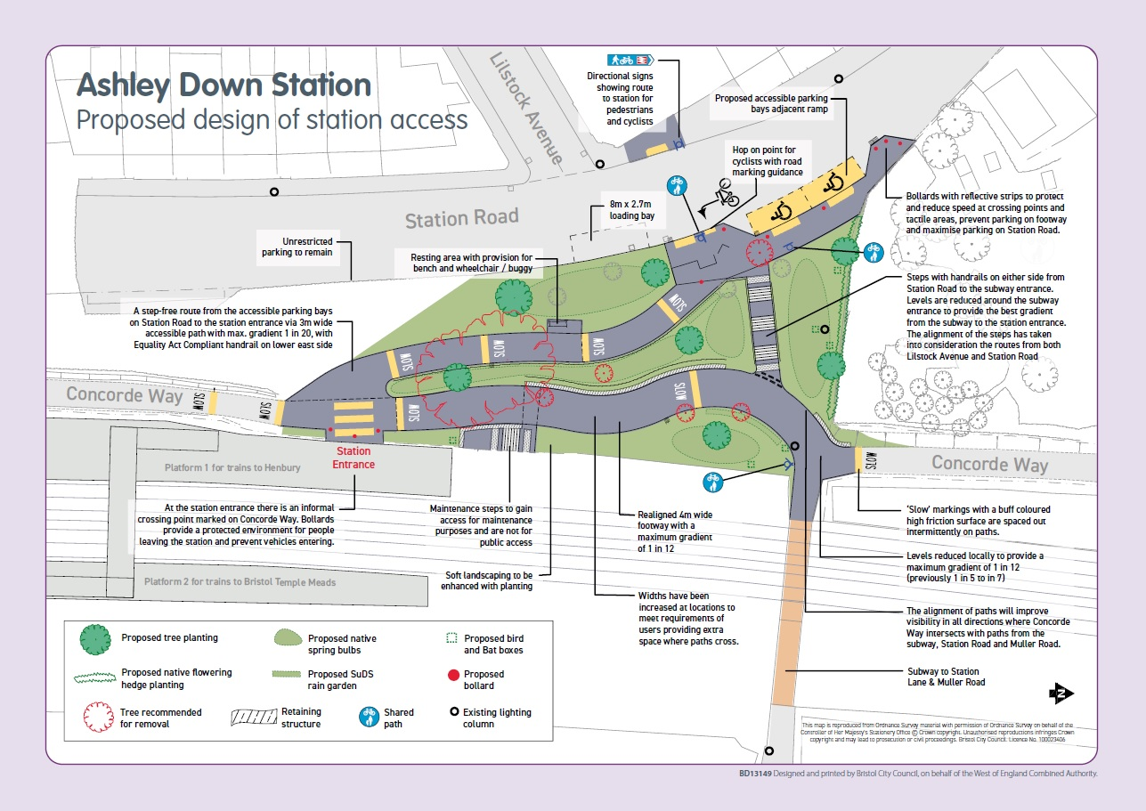

Bristol rail network map highlighting the new stations on the Henbury line as part of the MetroWest scheme
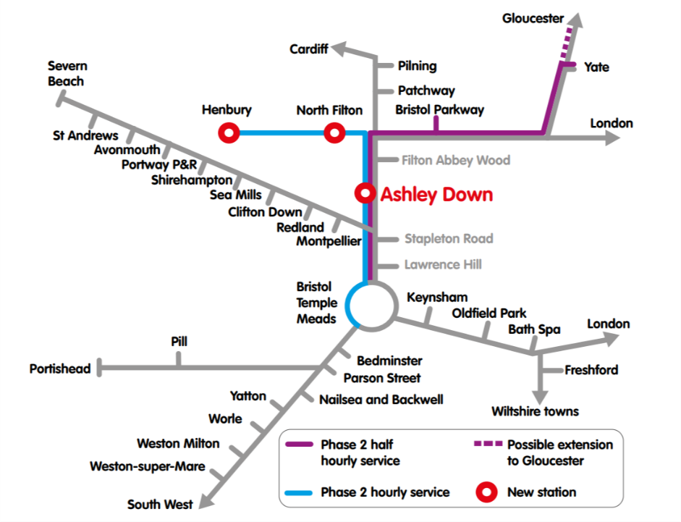
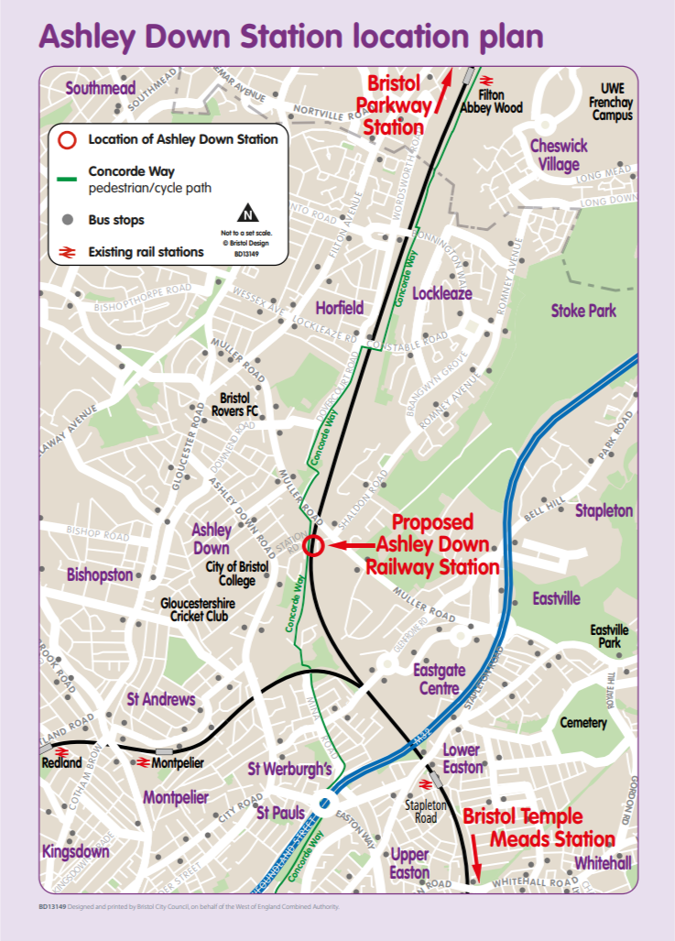

6.2.2 Computer-aided Design images and animation produced by Network Rail

6.2.3 Social media post
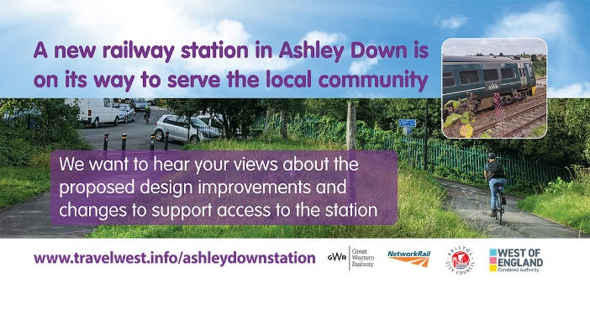

6.2.4 Postcard
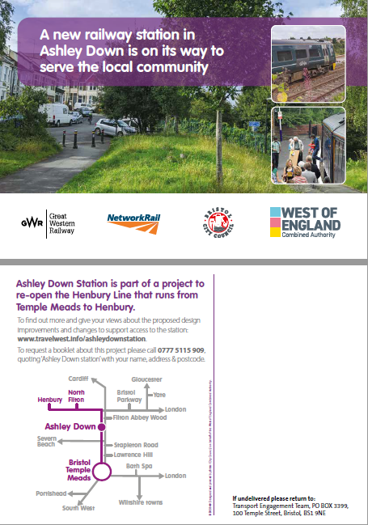

6.2.5 Poster
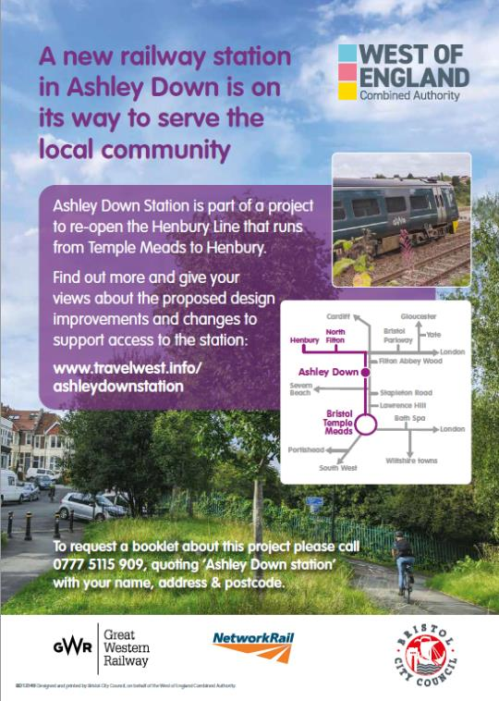

6.2.6 Vinyl banner
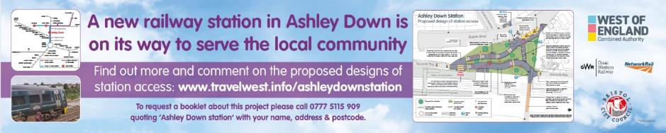

6.2.7 Booklet
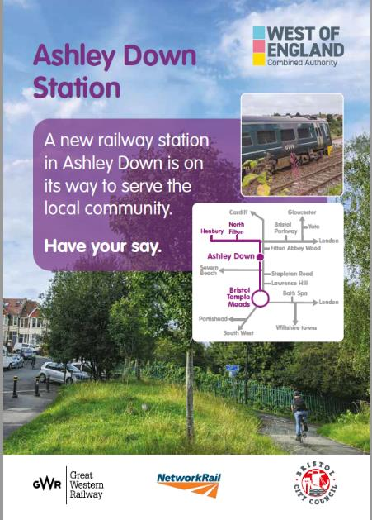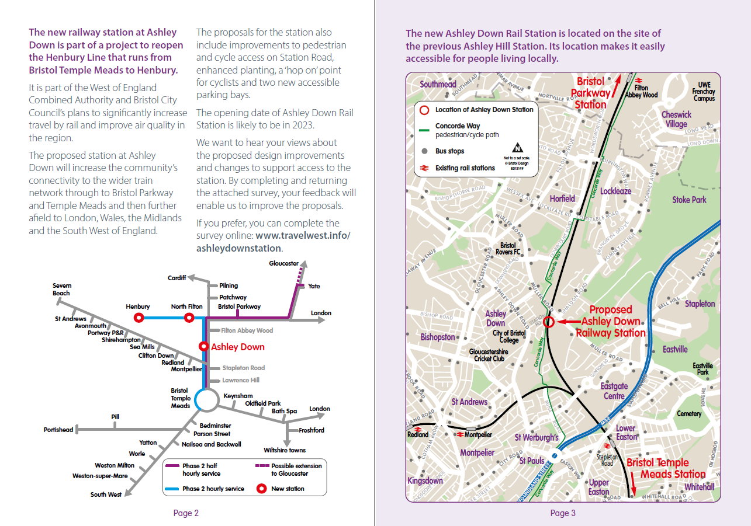
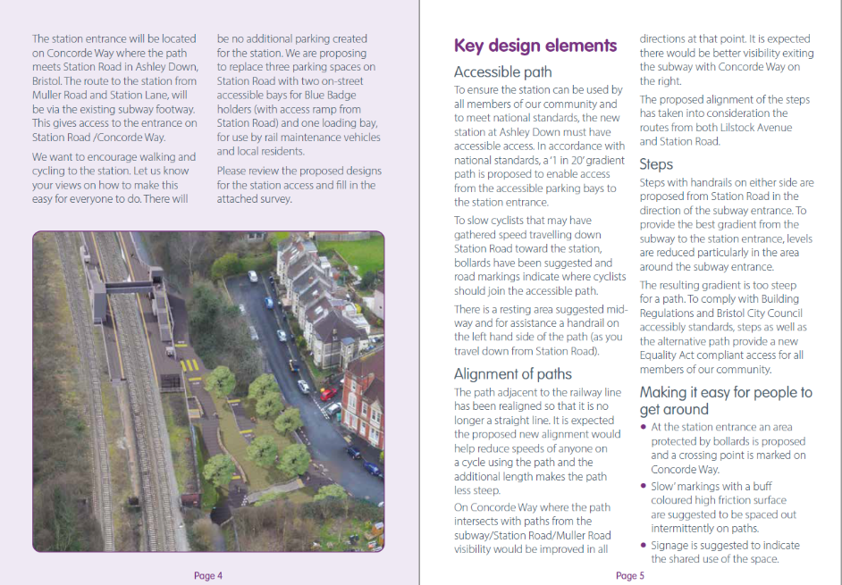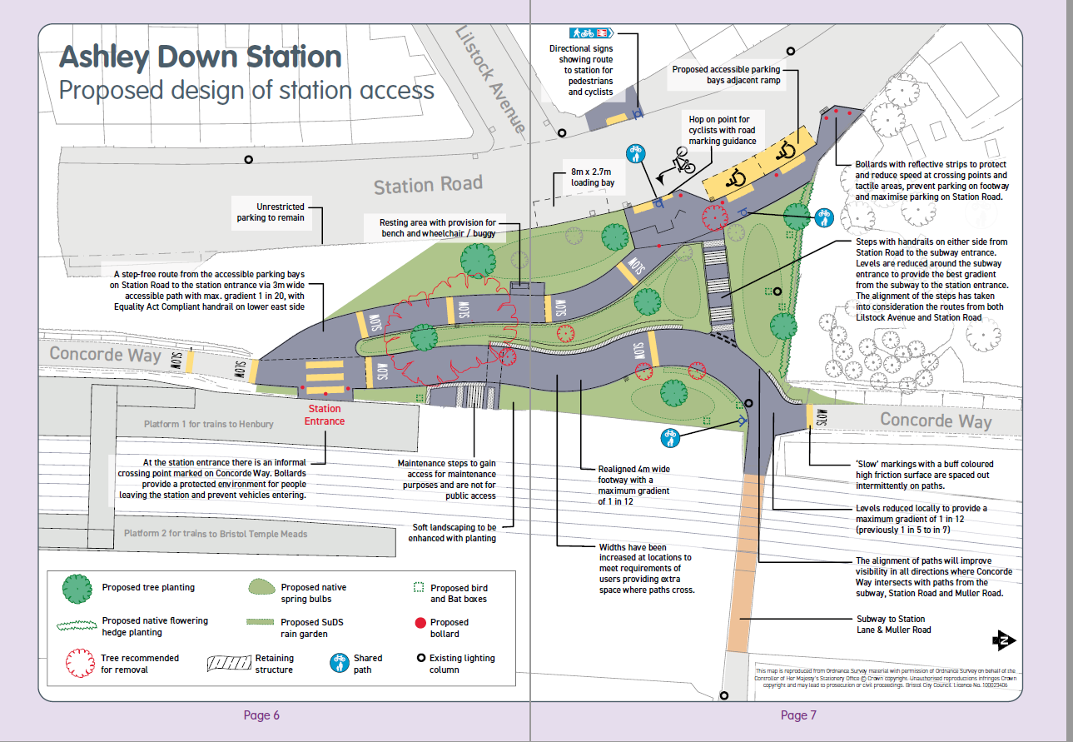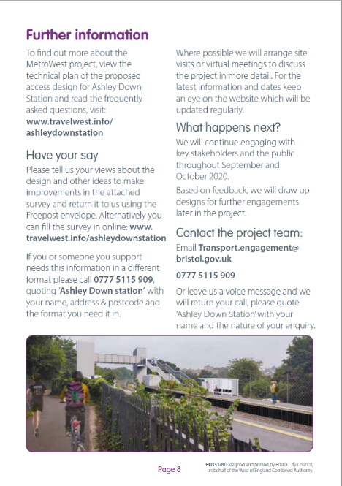

6.2.8 Survey
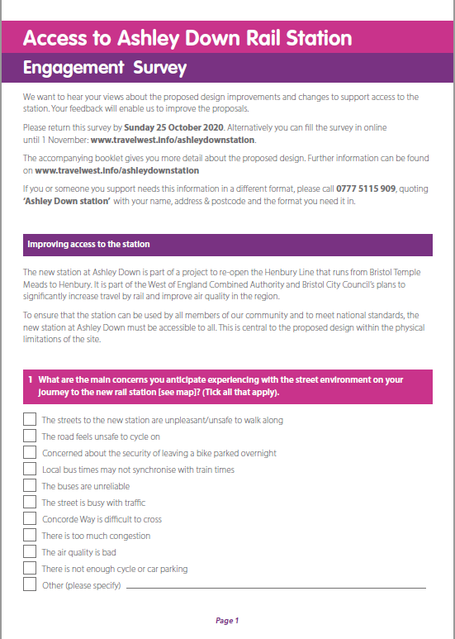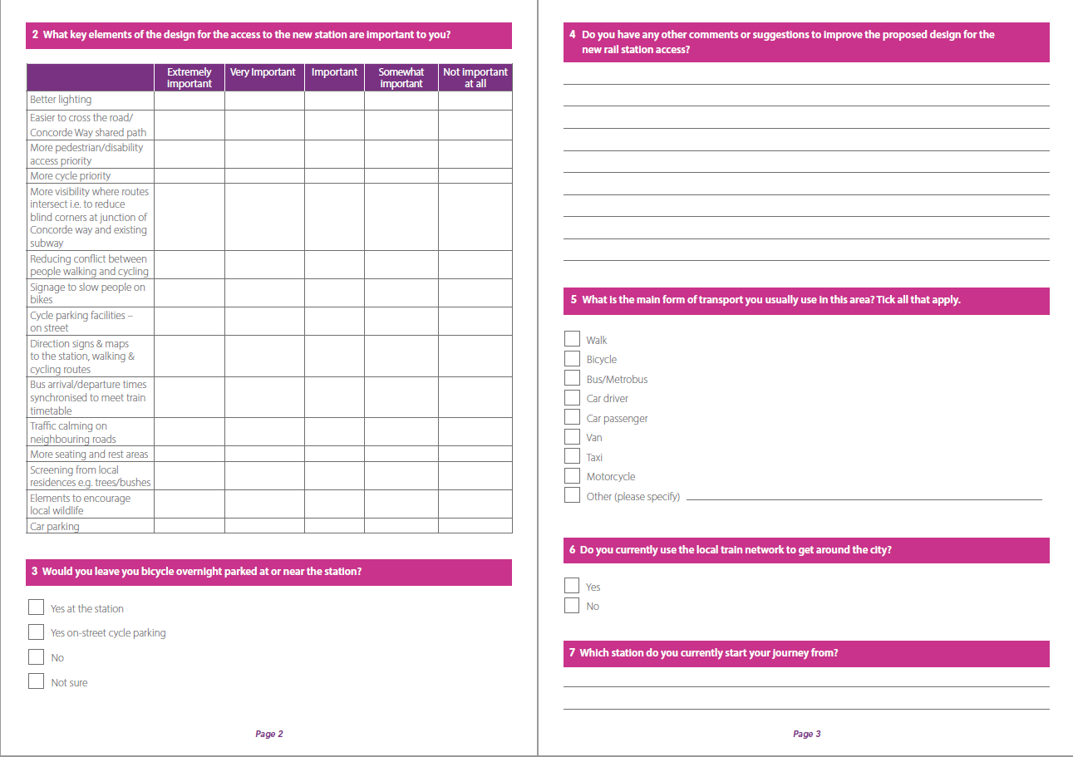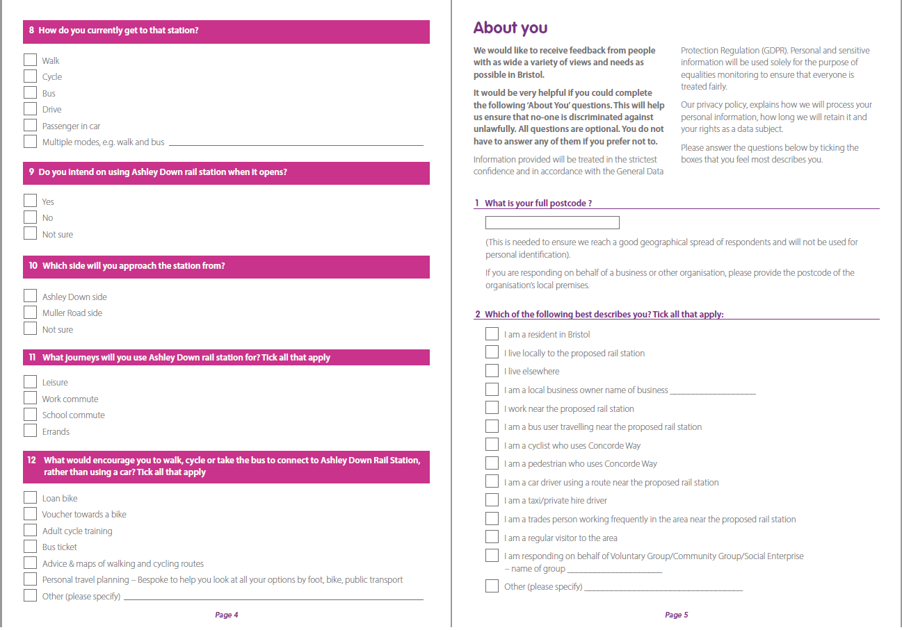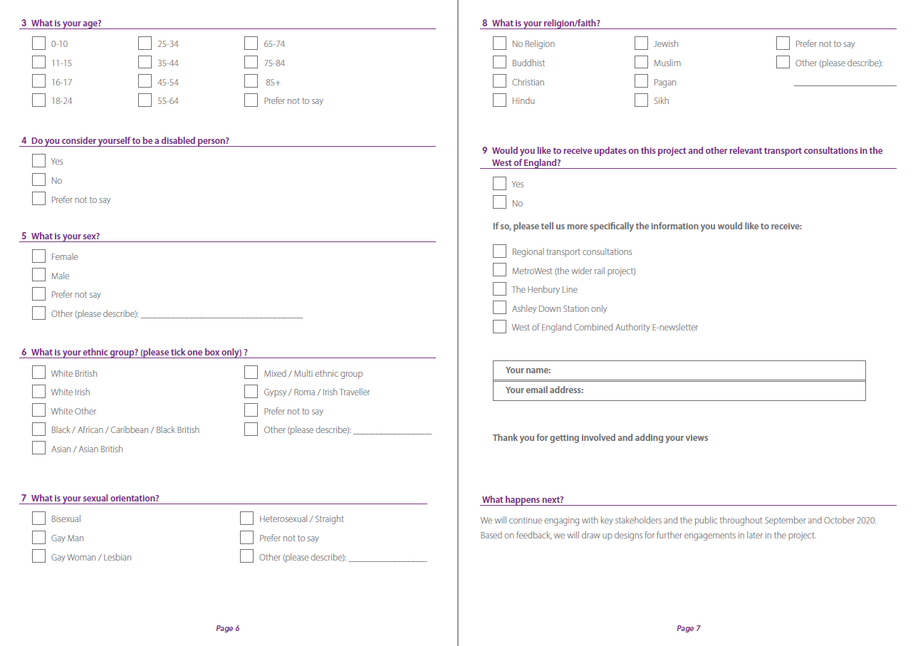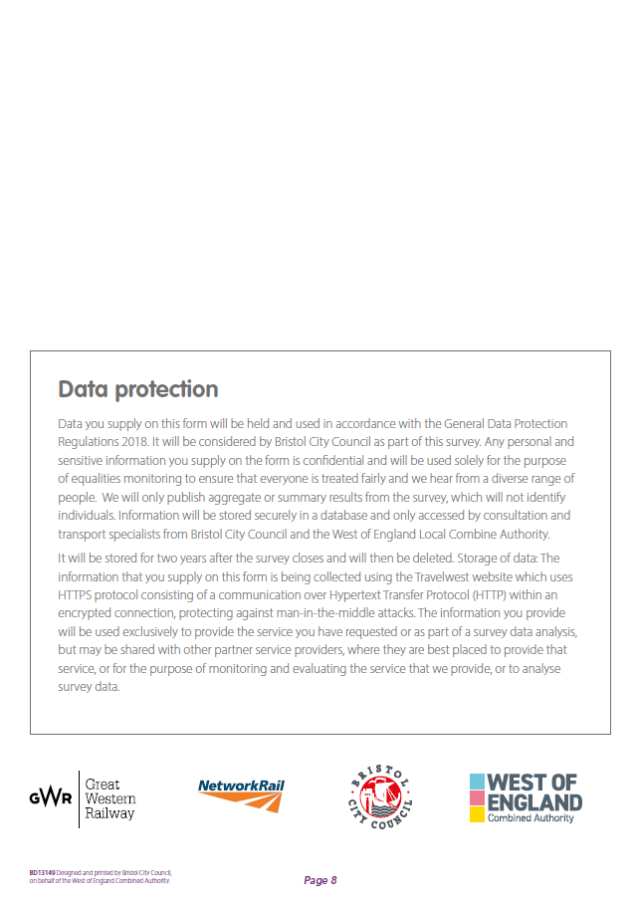

6.2.9 Social media schedule
Channel | Date | Time  (estimated) | Content
Facebook | 21 September 2020 | 5:45pm | Give your views on public access designs for the new Ashley Down railway station.  Ashley Down is one of the new stations being built as part of the MetroWest railway network, making it easier to choose sustainable transport into the city centre and around the country.  @westofenglandca and @bristolcouncil want to hear your views on the design of access to the station, so that it is accessible to all future users.  Your feedback will help us improve proposals. To have your say, visit www.travelwest.info/ashleydownstation before 1st November.
Twitter | 21 September 2020 | 5:30pm | We want your views on access designs for the new Ashley Down railway station.  As one of the stations being built in the MetroWest railways network, we want sustainable travel to be accessible for everyone.  Complete the survey by the 1st November: www.travelwest.info/ashleydownstation
Twitter | 24 September 2020 | 10am | Sustainable travel should be accessible to everyone.  Give your views on @westofenglandca and @bristolcouncil design proposals for public access for the new Ashley Down railway station.  Complete the survey before 1 November: www.travelwest.info/ashleydownstation
Twitter | 29 September 2020 | 12pm | Help improve proposals for Ashley Down train station!  Ashley Down is one of the new stations being built as part of the MetroWest railway network, and we want to hear your views on the design of access to the station.  Have your say before 1 November: travelwest.info/ashleydownstation
Twitter | 01 October 2020 | 3pm | New railway stations are coming!  Help shape designs for access to the new Ashley Down train station – another step on the journey to improved sustainable transport in the West.  Complete the survey before 1 November: www.travelwest.info/ashleydownstation
Facebook | 07 October 2020 | 10am | We want your feedback to help shape proposals for the new Ashley Down train station!  Ashley Down is one of the new stations being built as part of the MetroWest railway network, making it easier to choose sustainable transport into the city centre and around the country.  @westofenglandca and @bristolcouncil want to hear your views on the design of access to the station, so that it is accessible to all future users.  You can have your say now until 1st November. To find out more about the new station and complete the survey, visit travelwest.info/ashleydownstation
Twitter | 07 October 2020 | 8am | Give your views on access designs for the new Ashley Down railway station.  As one of the stations being built in the MetroWest railway network, we want sustainable travel to be accessible for everyone.  Complete the survey by the 1st November: www.travelwest.info/ashleydownstation
Twitter | 10 October 2020 | 10am | New accessible parking bays 🅿️  ‘Hop on point’ for cyclists 🚲  More plants 🌳  Sustainable travel accessed by everyone 💚  Give your thoughts on access proposals for the new Ashley Down train station by 1 November: travelwest.info/ashleydownstation
Twitter | 13 October 2020 | 12pm | Help improve proposals for Ashley Down train station!  Ashley Down is one of the new stations being built as part of the MetroWest railway network, and we want to hear your views on the design of access to the station.  Complete the survey by 1 November: travelwest.info/ashleydownstation
Twitter | 16 October 2020 | 10am | Sustainable travel should be accessible to everyone.  Give your views on @westofenglandca and @bristolcouncil design proposals for public access for the new Ashley Down railway station.  Complete the survey before 1 November: www.travelwest.info/ashleydownstation
Facebook | 19 October 2020 | 1pm | We want to make sure sustainable travel in the region is accessible to everyone.  Give your views on proposals for the design of public access for the new Ashley Down railway station.  Ashley Down is one of the new stations being built as part of the MetroWest railway network, making it easier to choose sustainable transport into the city centre and around the country.  @westofenglandca and @bristolcouncil want to hear your views on the design of access to the station, so that it is accessible to all future users.  You can have your say now until 1st November. To find out more about the new station and complete the survey, visit www.travelwest.info/ashleydownstation
Twitter | 19 October 2020 | 3pm | New railway stations are coming!  Help shape designs for access to the new Ashley Down train station – another step on the journey to improved sustainable transport in the West.  Complete the survey before 1 November: www.travelwest.info/ashleydownstation
Twitter | 22 October 2020 | 10am | New accessible parking bays 🅿️  ‘Hop on point’ for cyclists 🚲  More plants 🌳  Sustainable travel accessed by everyone 💚  Give your thoughts on access proposals for the new Ashley Down train station by 1 November: travelwest.info/ashleydownstation
Twitter | 27 October 2020 | 1pm | Time is running out to have your say on access designs for the new Ashley Down railway station.  Have your say by 1 November and help us make sustainable transport accessible to all.  travelwest.info/ashleydownstation
Facebook | 28 October 2020 | 5pm | Don’t miss your chance to give your views on the new Ashley Down railway station!  @westofenglandca and @bristolcouncil want to hear your views on the design of access to the station, so that it is accessible to all future users.  Our survey is only open for another 4 days – make sure to have your say.  To find out more about the new station and complete the survey by the 1st November, visit www.travelwest.info/ashleydownstation
Twitter | 30 October 2020 | 8am | Only 3 days left to have your say!  Ashley Down is one of the new stations being built as part of the MetroWest railway network, and we want to hear your views on the design of access to the station.  Complete the survey by 1 November: travelwest.info/ashleydownstation
Facebook | 31 October 2020 | 10am | Last chance to have your say!  West of England Combined Authority and Bristol City Council want to hear your views on the design of access to the new Ashley Down railway station, so that it is accessible to all future users.  Ashley Down is one of the new stations being built as part of the MetroWest railway network, making it easier for local people to choose sustainable transport into the city centre and around the country.  Our survey closes tomorrow – make sure you have your say.  To find out more about the new station and complete the survey by the 1st November, visit travelwest.info/ashleydownstation
Twitter | 31 October 2020 | 10am | Last chance to have your say! Survey closes tomorrow!  @WestofEnglandCA and @BristolCouncil want your views on the design of access to the new Ashley Down station, so that it is accessible to all users.  Complete the survey and find out more: travelwest.info/ashleydownstation

6.3 Social media engagement statistics
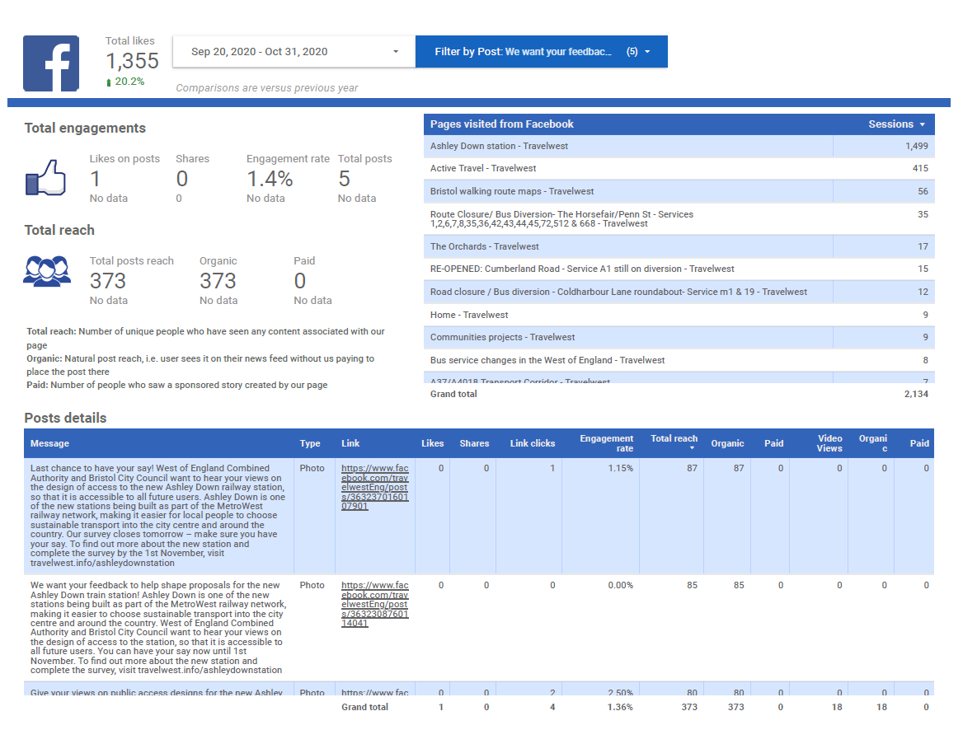
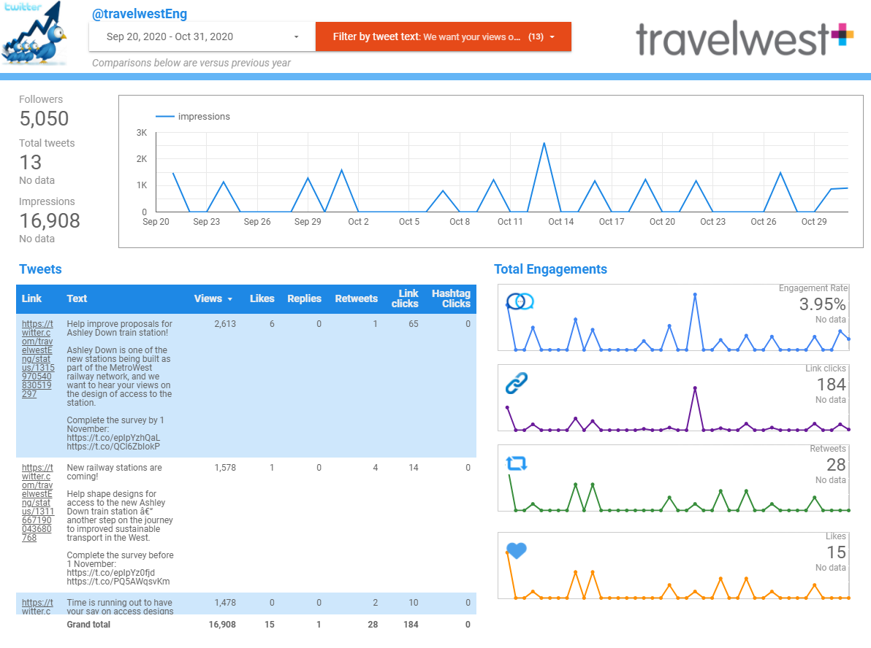

6.4 Stakeholder responses
Bristol Physical Access Chain (BPAC):
“thank you for this opportunity to tell you what we thought had been already agreed when BPAC had a site visit in April.

We started by looking at the approach to the station and realised there were no markings anywhere to show disabled people that a rail service was available for them.

To solve this problem it was suggested that a dropped kerb with the red bubbles should be put into the pavement opposite the approach which would allow wheelchairs to cross the road and become a tactile mark for those with a sight loss.

On crossing the road we noticed that the original path did not line-up , so it was suggested to move the path and reduce the slope so that wheelchairs or some older people could manage the incline. There was a seat already in place but it was too low and so a new seat was planned which would be higher and have arm rests which could also give assistance to people trying to stand. Also we asked if an edge could be built into the path so visually impaired people could follow it easy using a long white cane.

`The path at this point turned slightly left to go towards the tunnel taking people towards Muller Road. But we were more concerned for peoples: safety as this is where the pedestrians and cyclists meet.

We asked for special consideration here in the form of extra lighting, bumps on the road to slow down the cycles, and also bright markings on the path to tell the pedestrian that they were walking on a cycle path and should take care. Extra signage was suggested to make cyclists aware that this was now a station approach and that they should slow down.

We were also worried about the door or gateway into the station. At present it has a single bollard in the middle but does in no way stop children or anyone else entering the station and using it as a play area as it is unattended. We asked for gates which might be unlocked using the RADAR key.

If you are coming off a train and walking out of the station, we feel that a paved area across the front would give passengers a chance to stop, take a breath, before moving to their parked car or walking away.

Extra lighting was suggested at this point to allow passengers to see clearly if cycles are near and also alert the cyclists that they were riding through an area which people used every day.

When you visited BPAC I did not understand the arrangements that were on your plans for disabled parking. It was agreed on our visit that disabled parking should be to the Right of the entrance to the station so people could park easily with room for opening a big car door , as in a 2 seater car. These would be marked and sized correctly and a notice placed on the wall for all to see.

We were also told that National rail had the responsibility for the changes made on the station itself but that we would have a chance to meet them at a later date. This never happened so I would like to discuss these plans with the rail authorities to see if we might make some recommendations to help disabled people have a good access around the station.

I am forwarding this email to the chair of BPAC (Bristol Physical Access Chain) so we can discuss it at a later time. to obtain the best results as this is the first of many we might have to audit over the coming years.”

Bristol Cycling Campaign:
For the Ashley Down Station Consultation, Bristol Cycling Campaign would like to respond with the below statement.
Bristol Cycling Campaign welcome the proposal to reduce the gradient on the section of Concorde Way adjacent to Station Lane subway, which will help improve the desirability, safety, and accessibility of the route. We fully support the plan to include covered CCTV monitored cycle parking spaces within the station.
However, whilst the arrangement of the access ramp from Station Road means that pedestrians and cyclists coming from the West Side of the Station (e.g. Ashley Down) only need to cross rather than traverse along Concorde Way, we are concerned that the Station will lead to significant numbers of pedestrians in particular using Concorde Way to access the station from the south (e.g. St Werburghs) and the north (e.g. Muller Road). These sections of Concorde Way are narrow and already congested shared use paths, and without improvements this will further increase conflict between users. We call on MetroWest to widen these sections of Concorde Way as part of the scheme, to achieve fully segregated provision in accordance with LTN 1/20 which will improve the route for all users.
You can out more about Bristol Cycling Campaign at https://bristolcycling.org.uk/ and are welcome to get in touch with any queries
Bishopston Cotham and Redland Street scene (BCR):
“Many new walls are being erected as part of this project. Given the focus of illegal graffiti around stations, and the existing level of graffiti and tagging in this area, we are very concerned that the design has not taken account of this issue. in order to cut down on maintenance and to prevent an area which generates a fear of safety and crime, we suggest that this is reconsidered and masonry surfaces are replaced with greenery and easily power washable surfaces where hedges and plant screens are not possible to reduce this potential problem.”
Principal of Fairfield High School:
“In general we are totally in favour of the scheme - will massively help green transport links and employees get to work for us. We’d want to see improved access via the railway underpass - currently a wholly unsuitable place to walk / cycle really - could be so much better.”

Healthy Streets Indicators were developed by Lucy Saunders and were adopted by Transport for London https://healthystreets.com/home/about/

